**REPORT ABOUT MY WEBPAGE**

**Student Name: Nguyễn Thị Ngọc Thảo**

**Student ID: 2201040167**

**Tutorial Class: PCO 06**

1. **Overview**
   1. Topic of your project

In the ever-evolving journey of human development, our needs extend beyond the material realm, delving into the profound questions about ourselves and the universe. This growing desire has created an increase in the demand for profound self-awareness and deeper relationships with the cosmos. This quest for self-discovery and spiritual progress inspired me to create a free astrology and divination website that effortlessly incorporates three critical domains: Star Charts, Numerology, and Zodiac Signs.

Natal Charts: These charts help us connect with the universe by showing how planets and stars influence our lives and personalities.

Numerology: It's like a secret code that reveals the meaning of numbers tied to our birthdate and name.

Zodiac Signs: This explores our traits and future possibilities based on our astrological signs.

Uniquely, to carve out a distinct identity for this platform, I coined the name "HIPPO," where each letter carries significant symbolism:

H - Harmony: Representing the pursuit of harmony and balance in life.

I - Insight: Symbolizing profound insight into life, soul, and the future.

P - Personal Growth: Acknowledging the importance of personal development.

P - Prediction: Emphasizing the crucial role of prediction in astrology.

O - Occult: Reflecting the mysterious and supernatural aspects of divination.

In essence, the name "HIPPO" encapsulates a pursuit of harmony, wisdom, personal growth, predictive abilities, and the enigmatic realms of divination. In summary, the "HIPPO" website serves as a rich, freely accessible resource aimed at aiding individuals in achieving a deeper understanding of themselves, fostering connections with the universe, and uncovering the subtle intricacies of life.

* 1. Technology used

My webpage is predominantly built with HTML and CSS, comprising 16 HTML pages, 16 CSS files, and 1 JavaScript page, distributed as follows: HTML: 60.2%, CSS: 39.7%, and JavaScript: 0.1%. In addition, I have integrated the following external resources:

* Bootstrap 3.4.1: A CSS and JavaScript framework used for designing and structuring the website's interface.
* jQuery 3.6.4 Library: This JavaScript library empowers the website with event handling and interactive capabilities.
* FontAwesome and Boxicons: These icon and vector libraries enrich the visual aspect of the website by providing a wide array of beautiful icons and vectors.
* Google Fonts: I have linked to Google Fonts to access custom fonts for the site.

Furthermore, I have utilized Canva, a graphic design tool, to create the logo and several images to align with the website's theme and overall aesthetics.

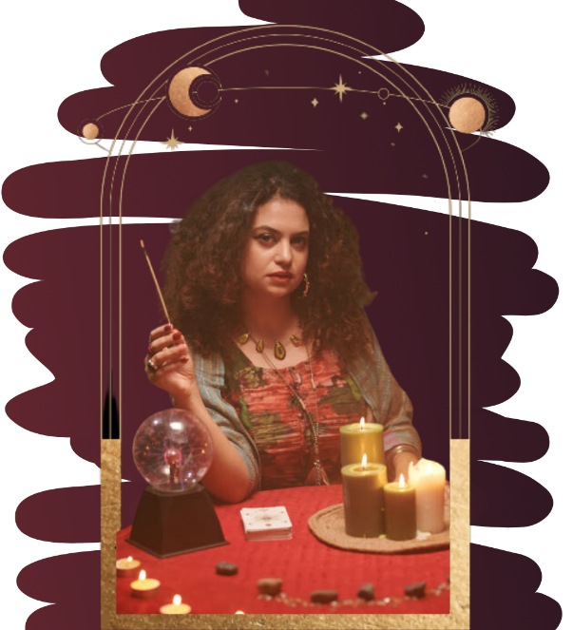 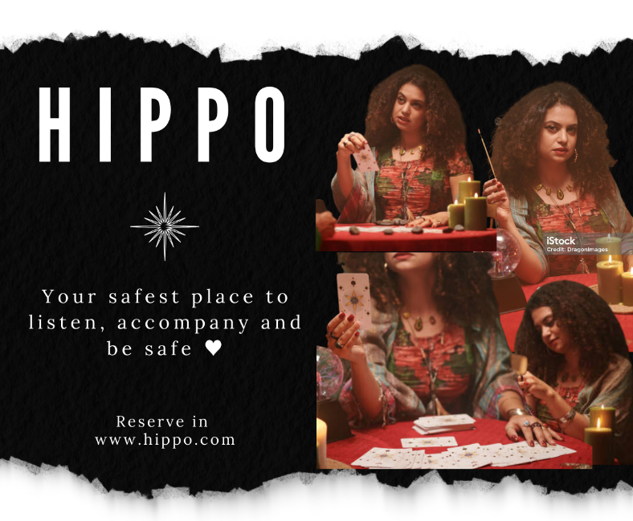

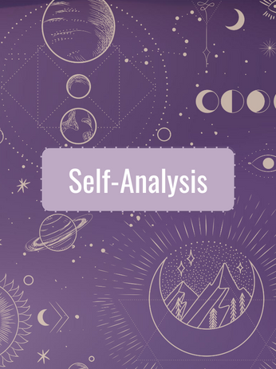 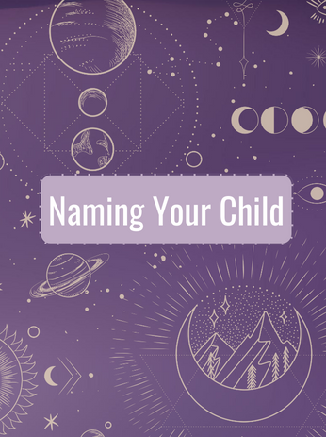 

 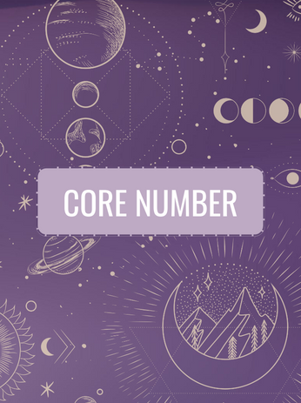 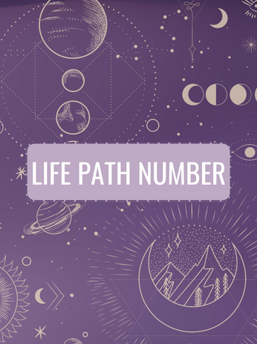

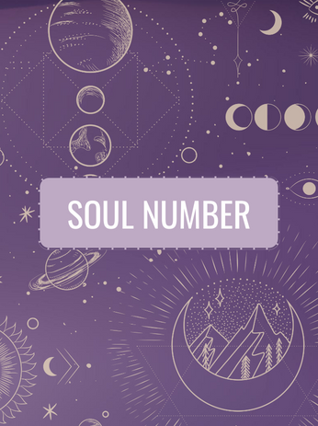 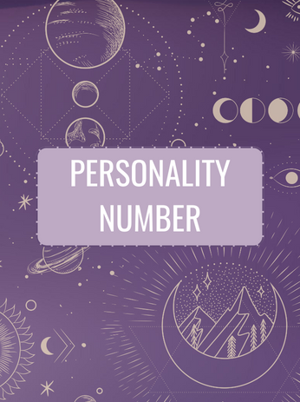 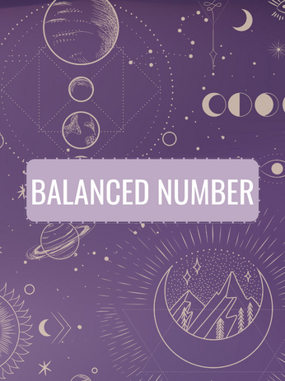

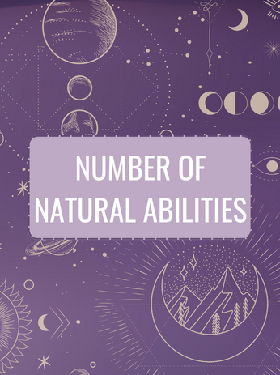 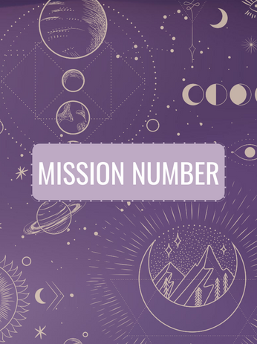 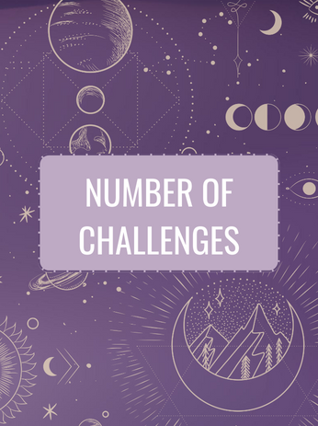

 

1. **Result**
2. **Code file (16 HTML files + 16 CSS files + 1 JavaScript file)**

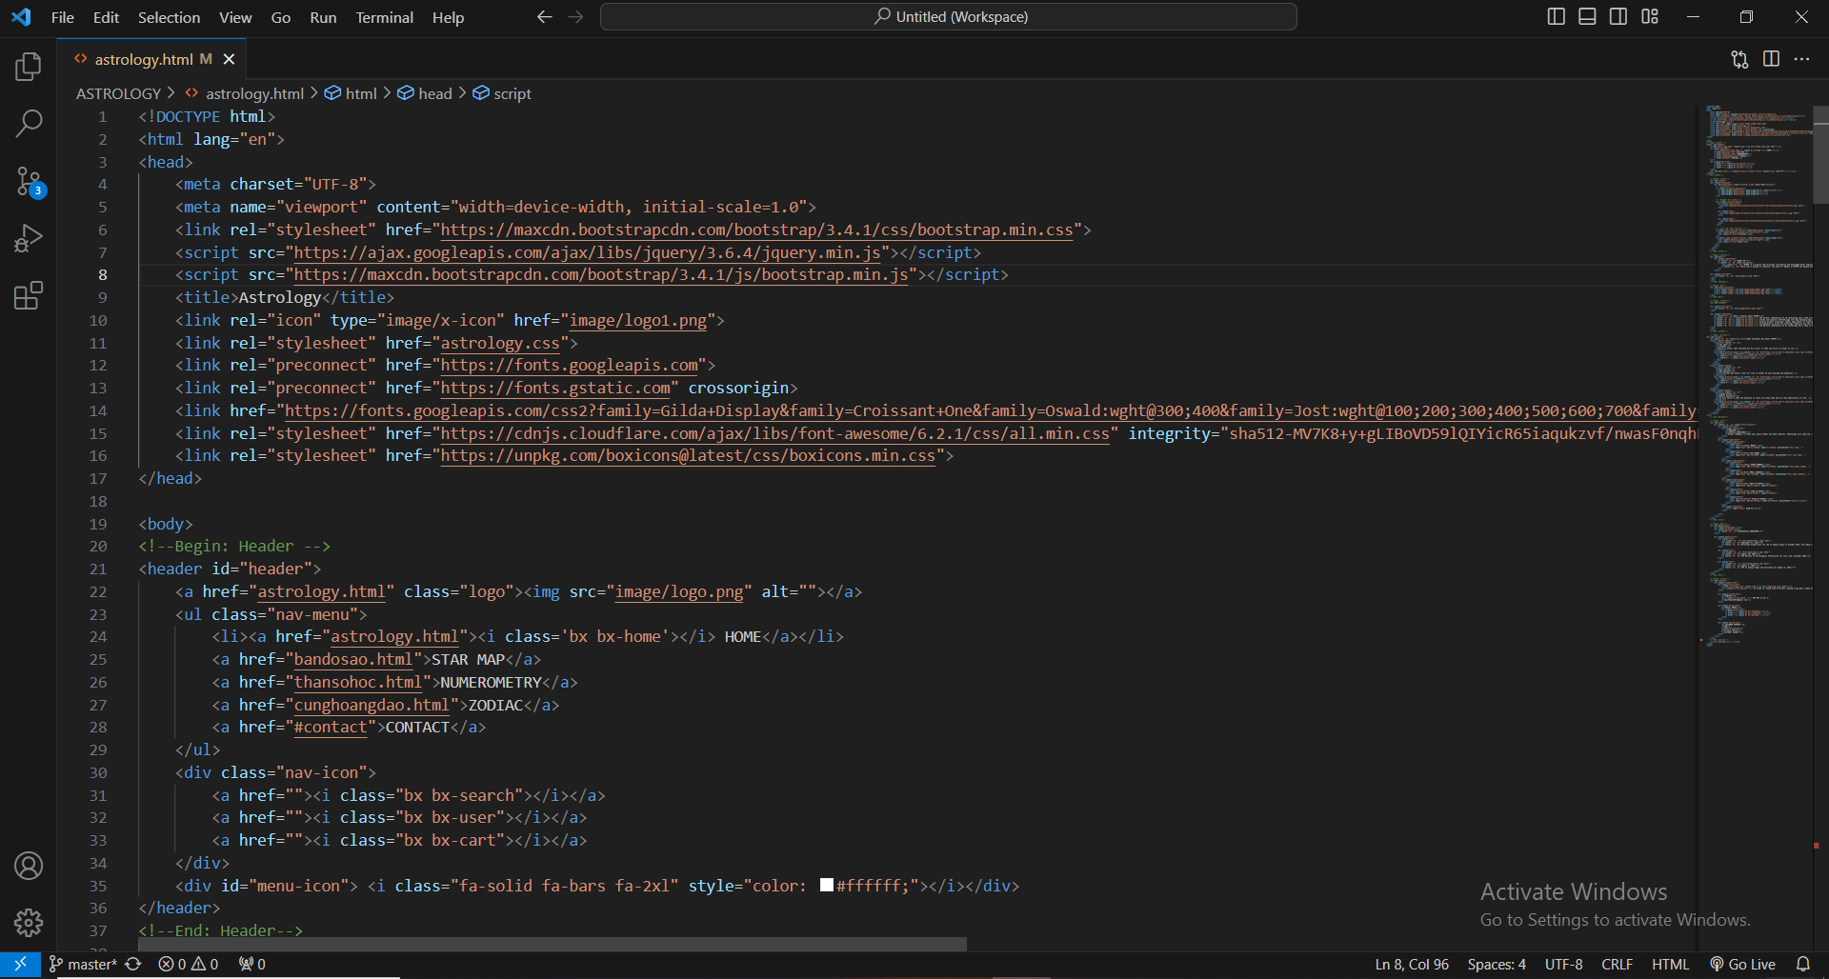

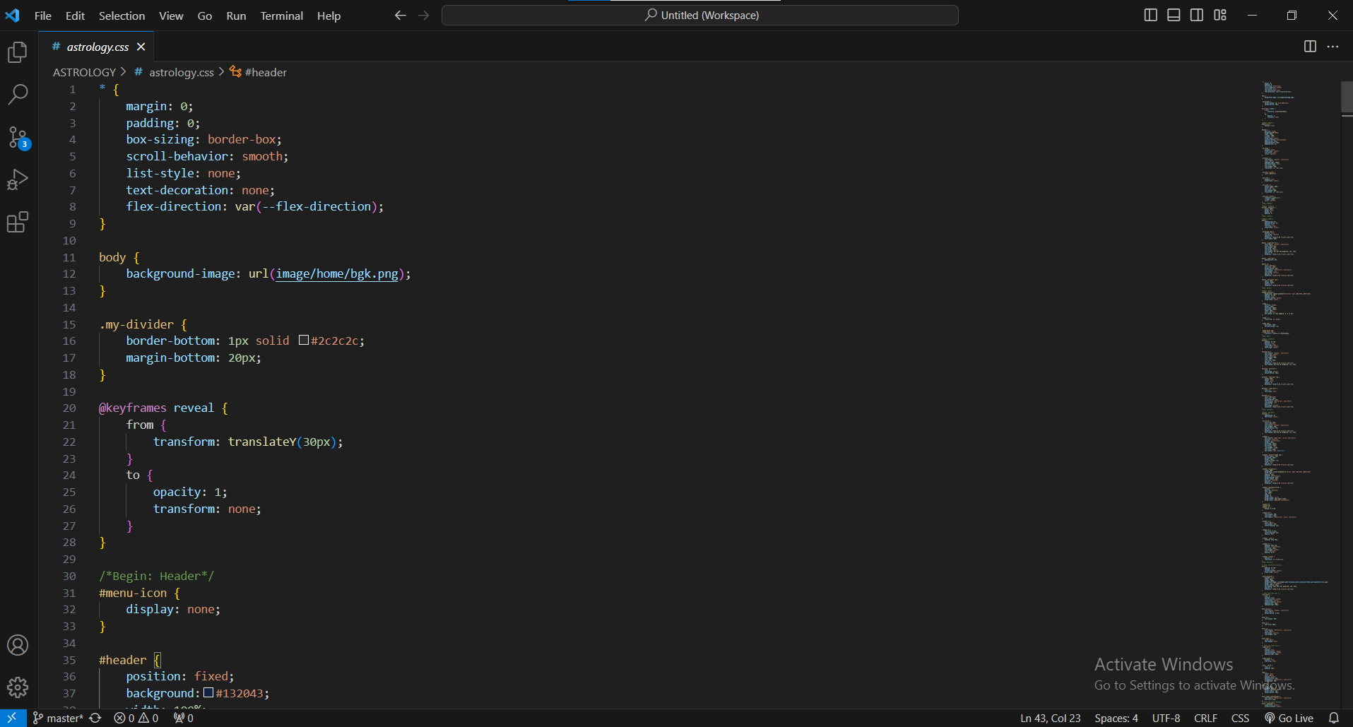

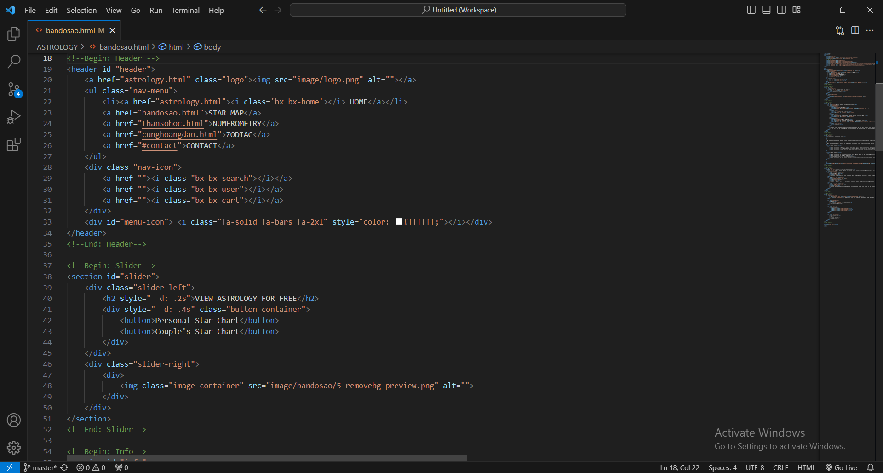

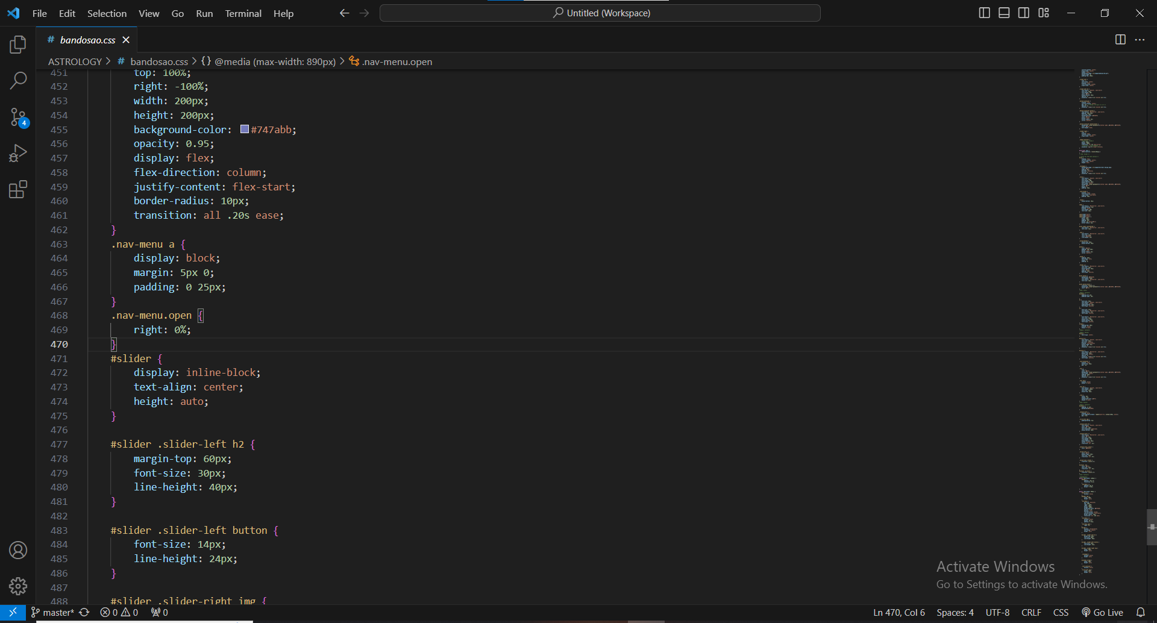

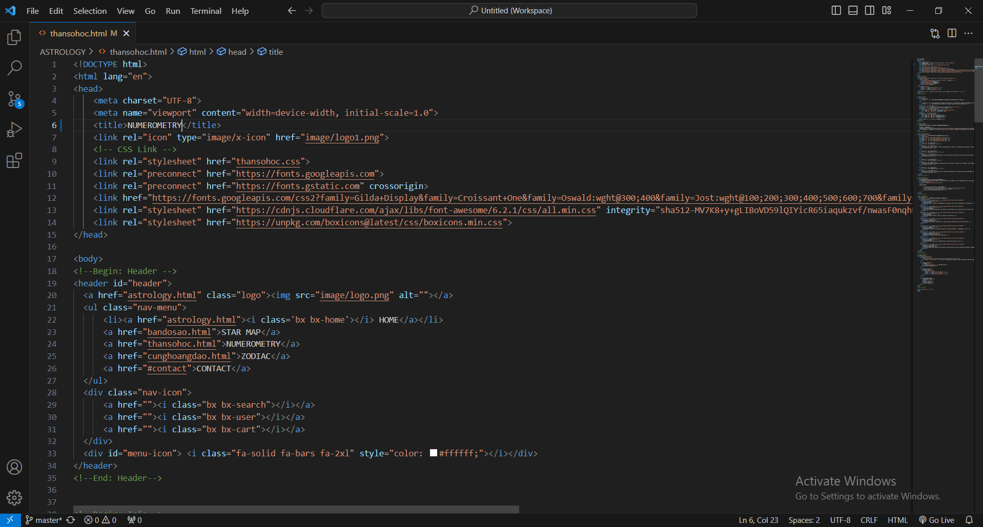

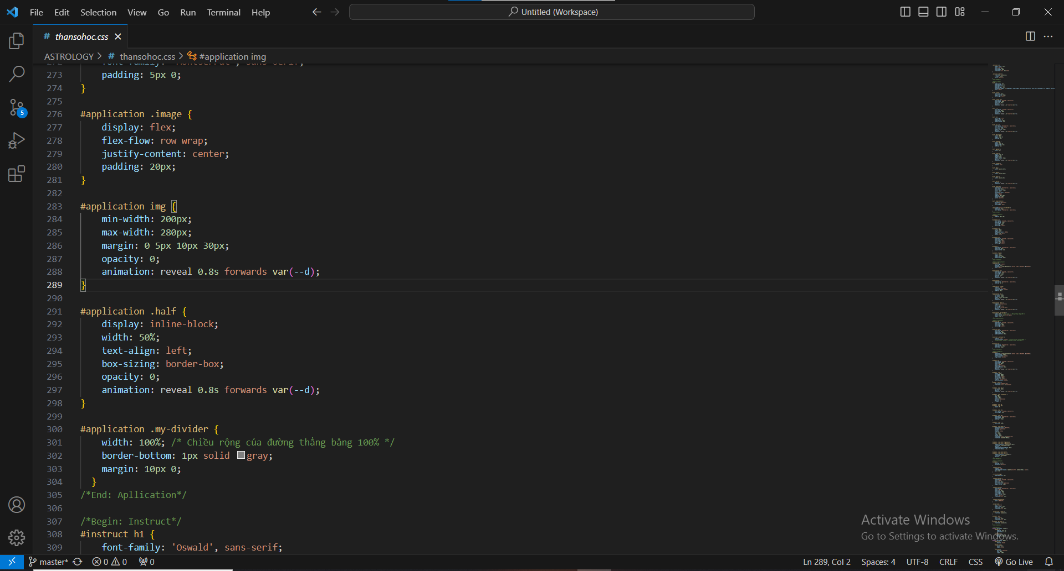

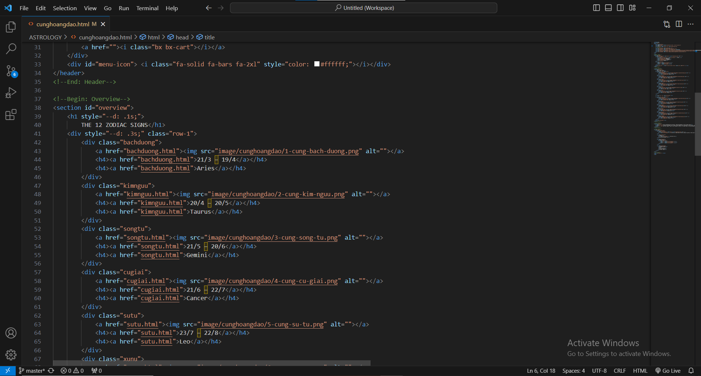

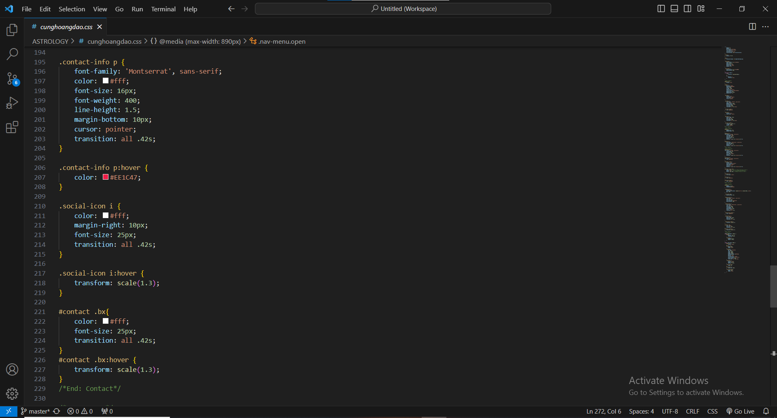

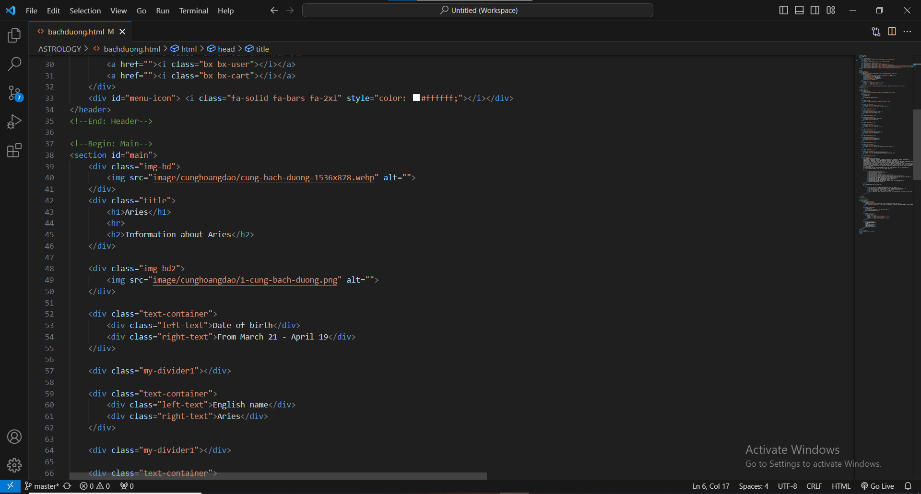

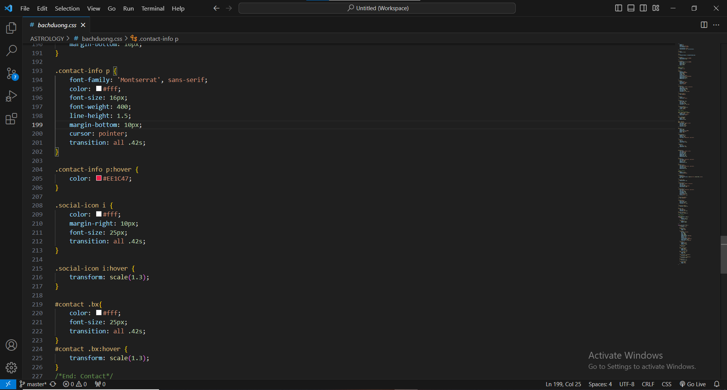

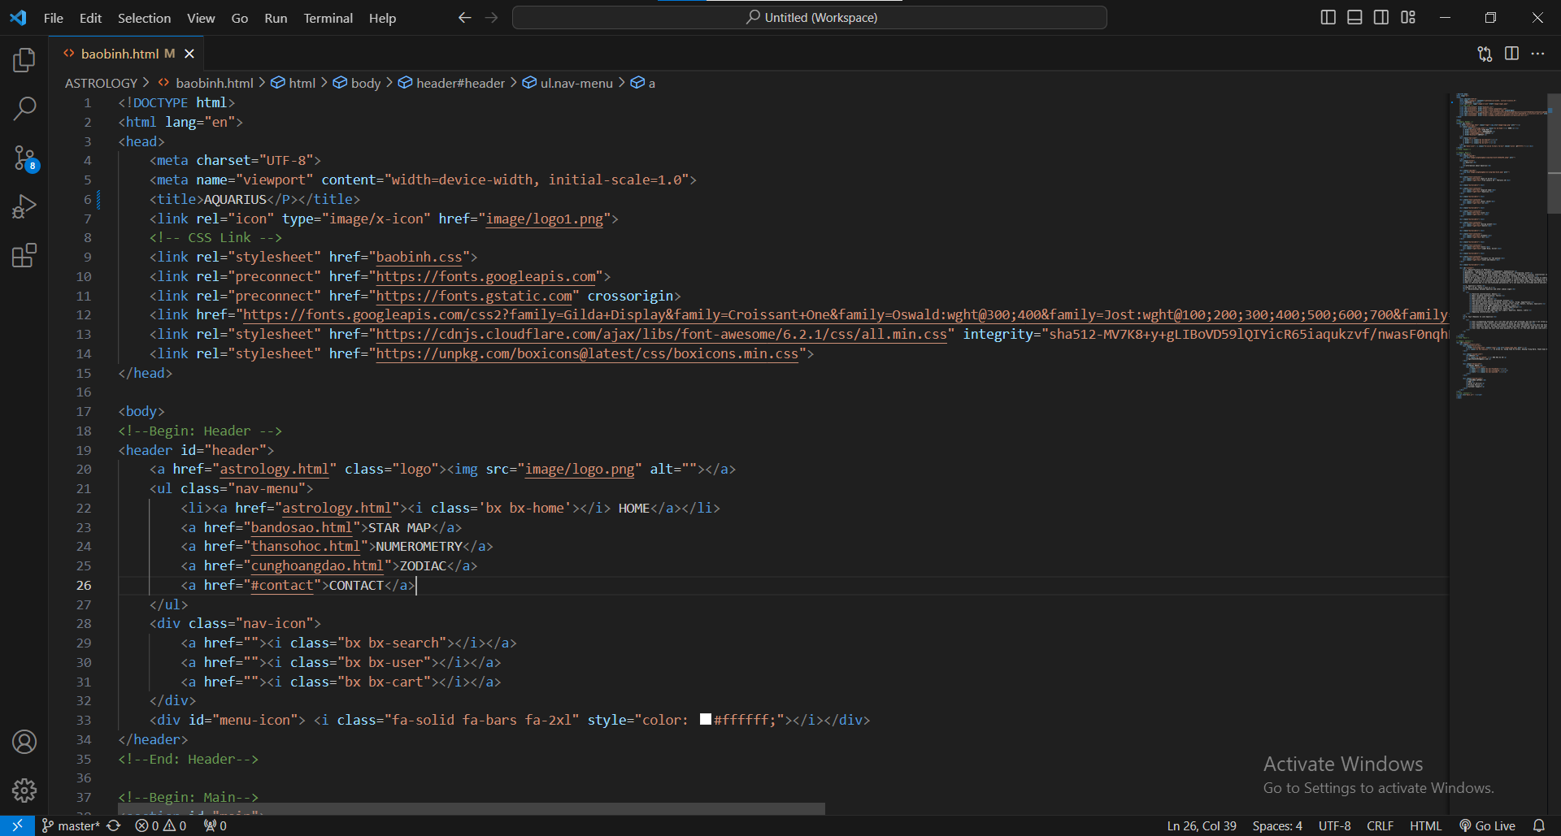

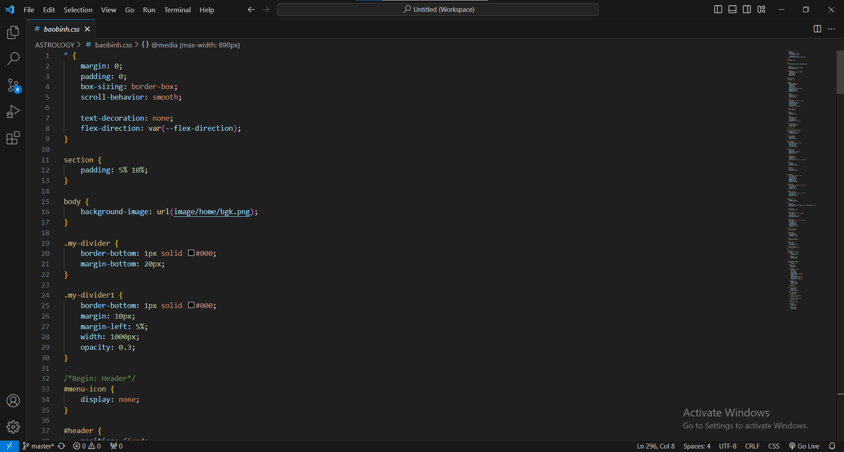

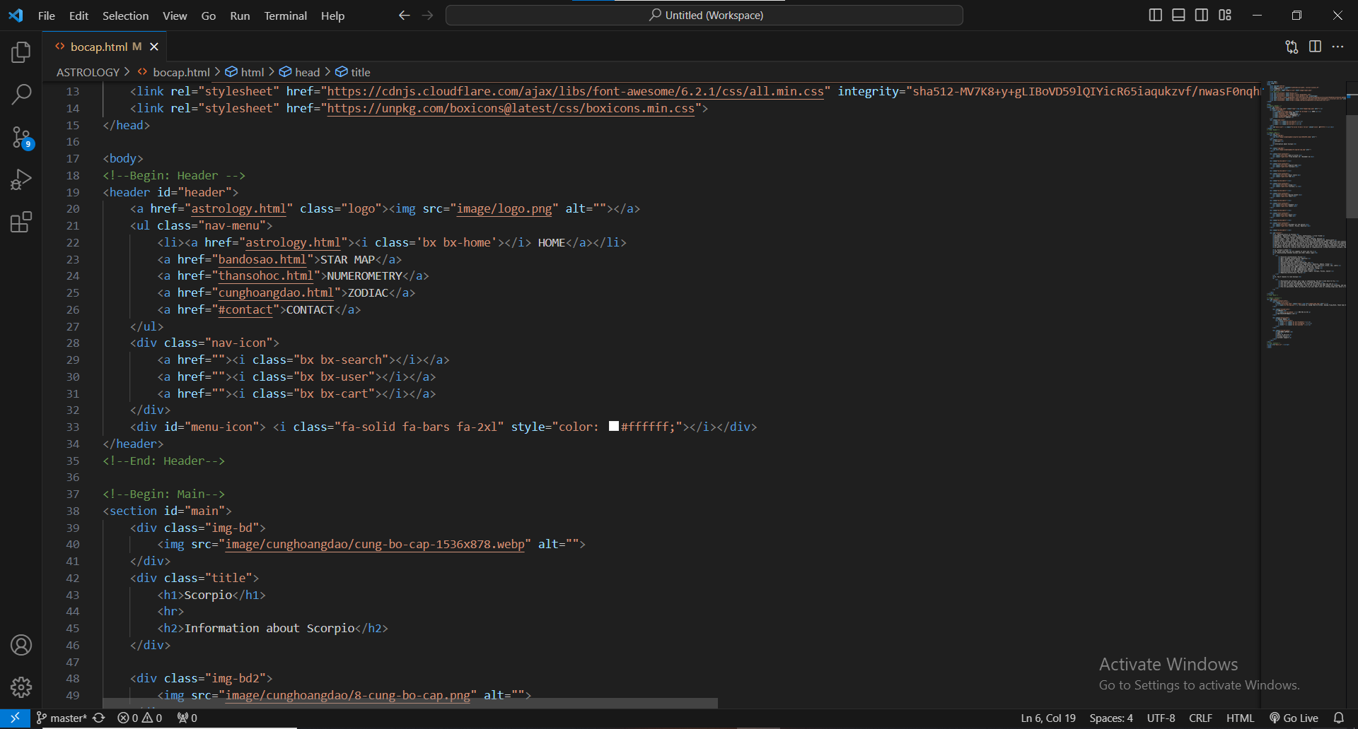

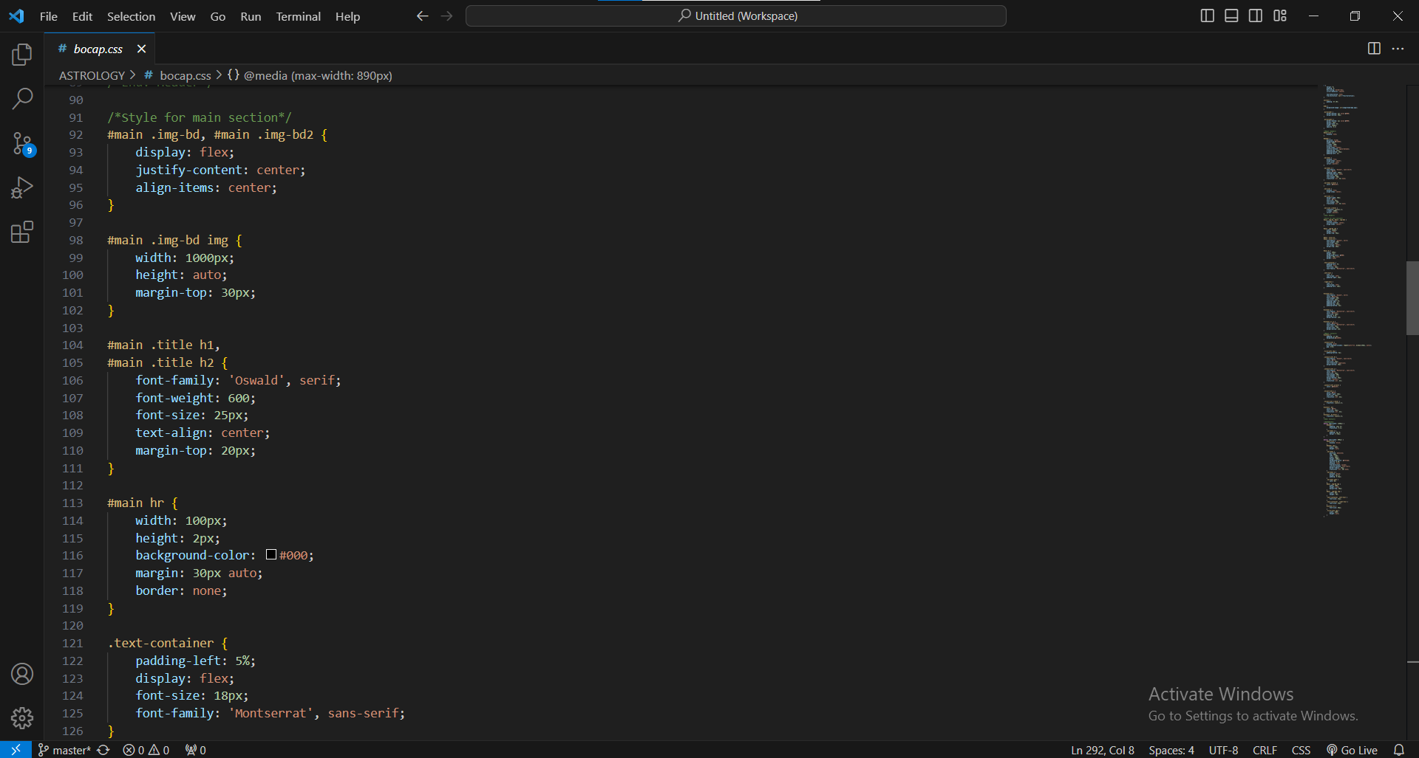

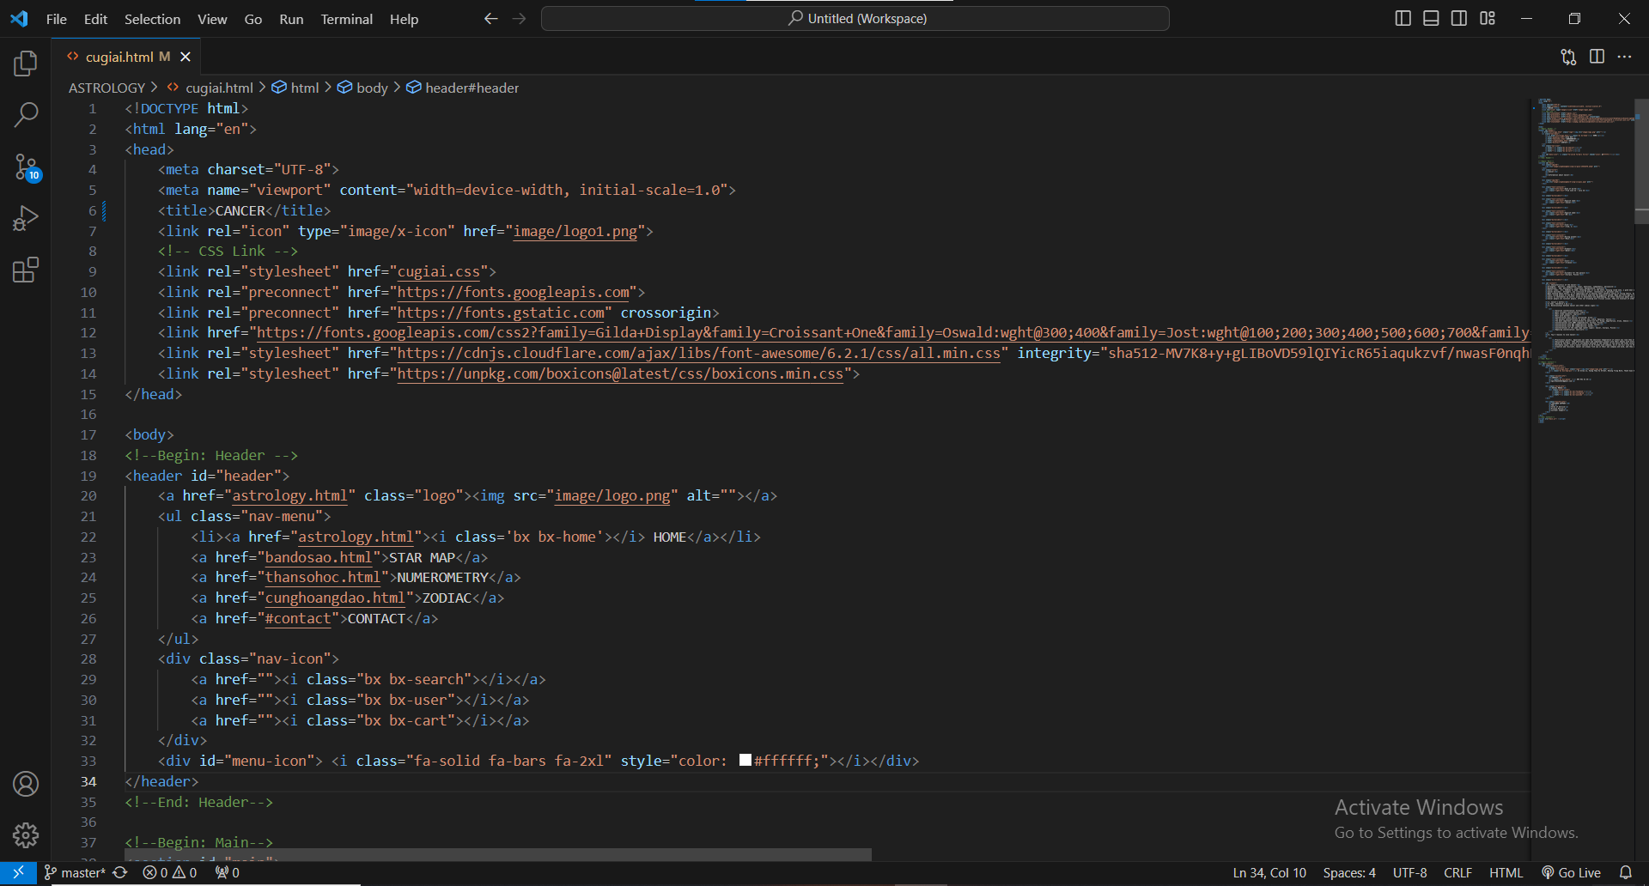

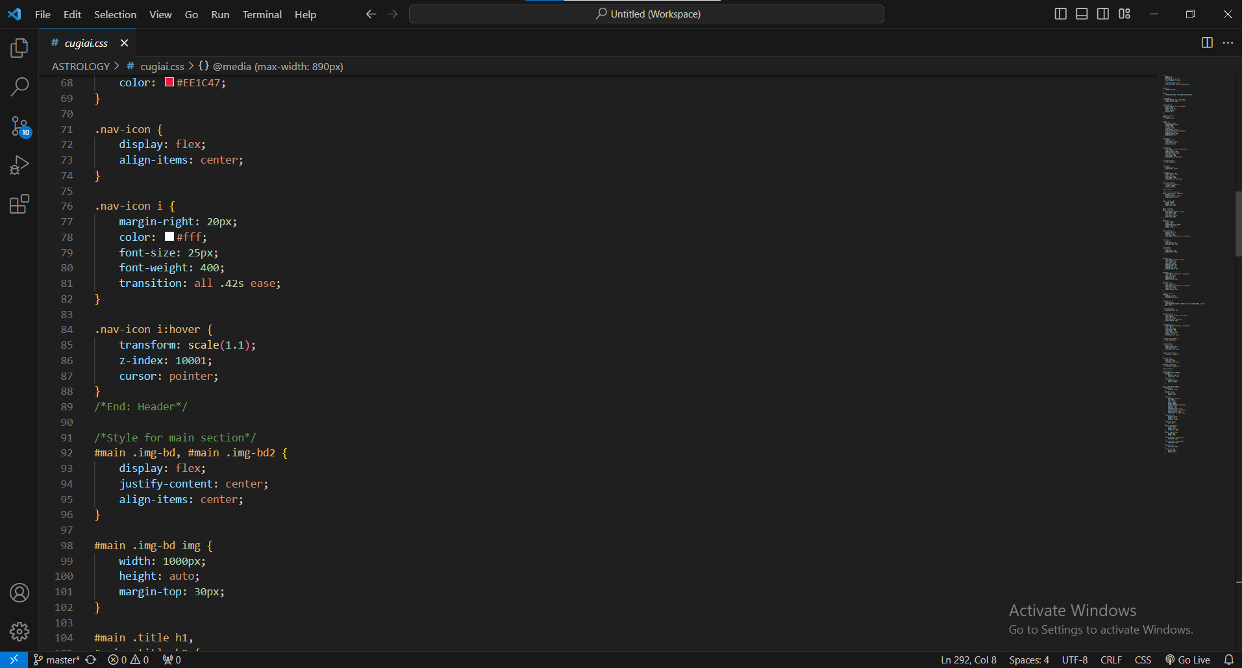

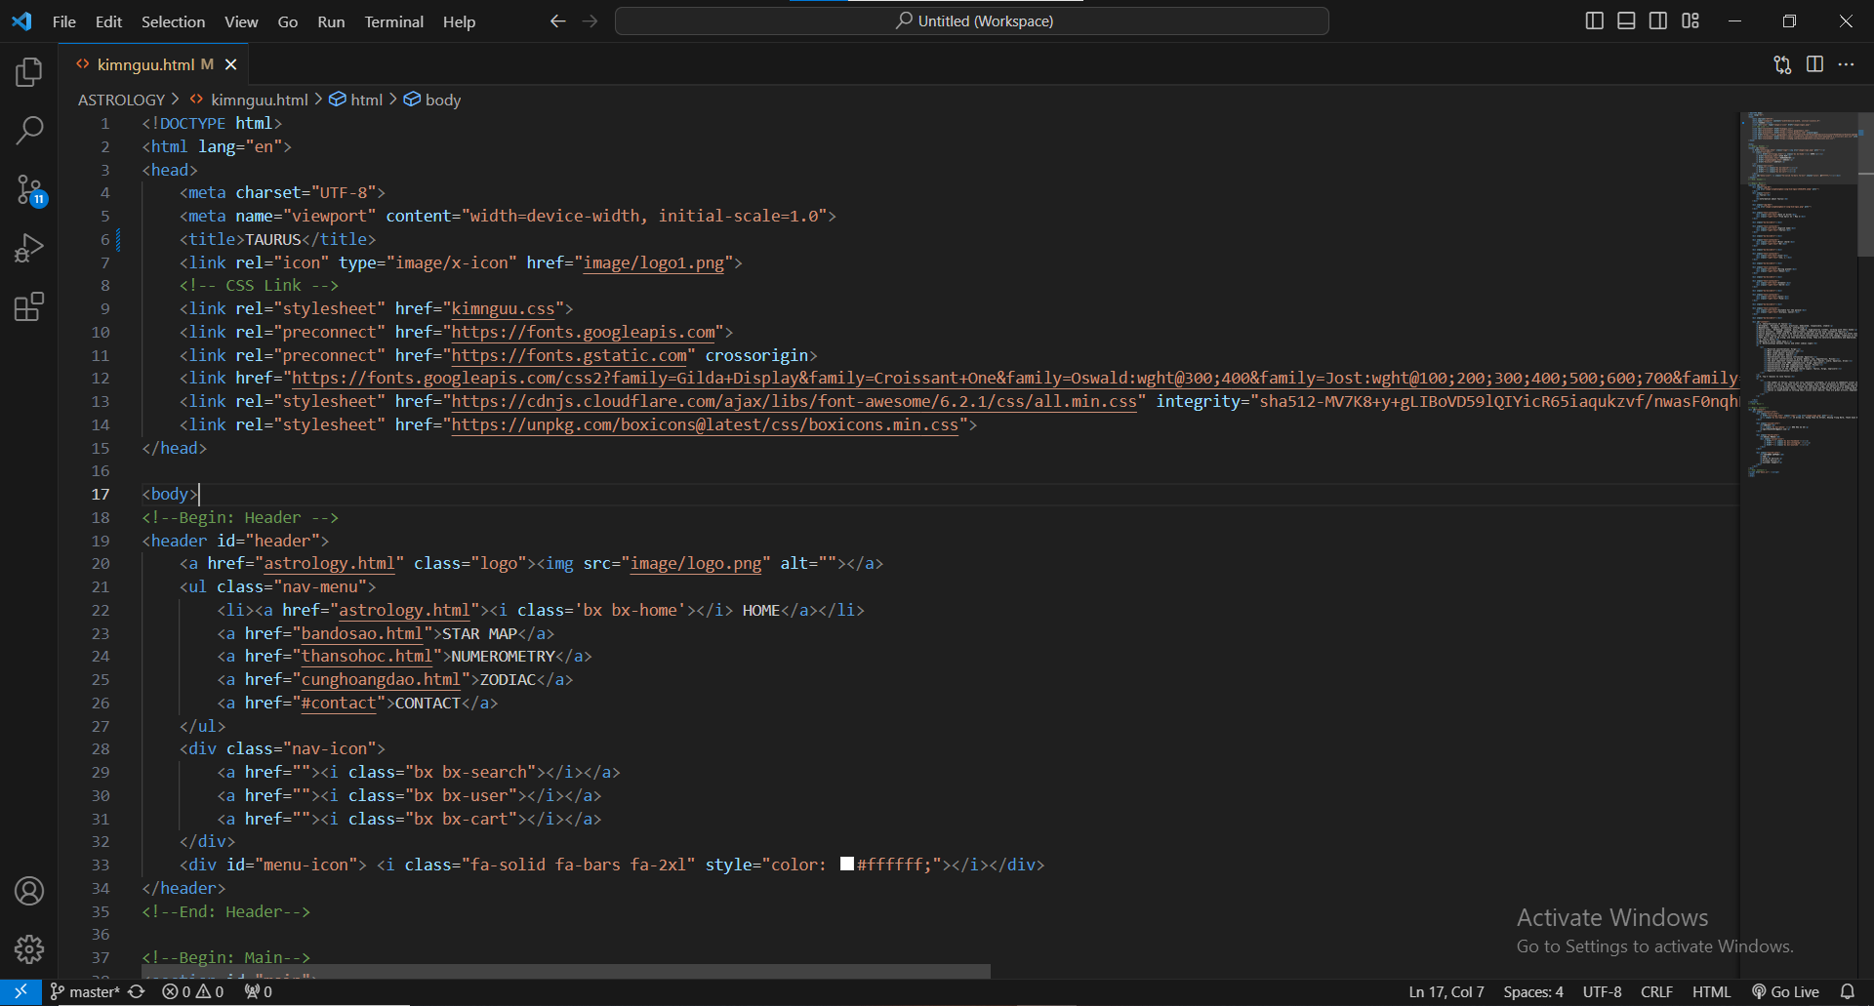

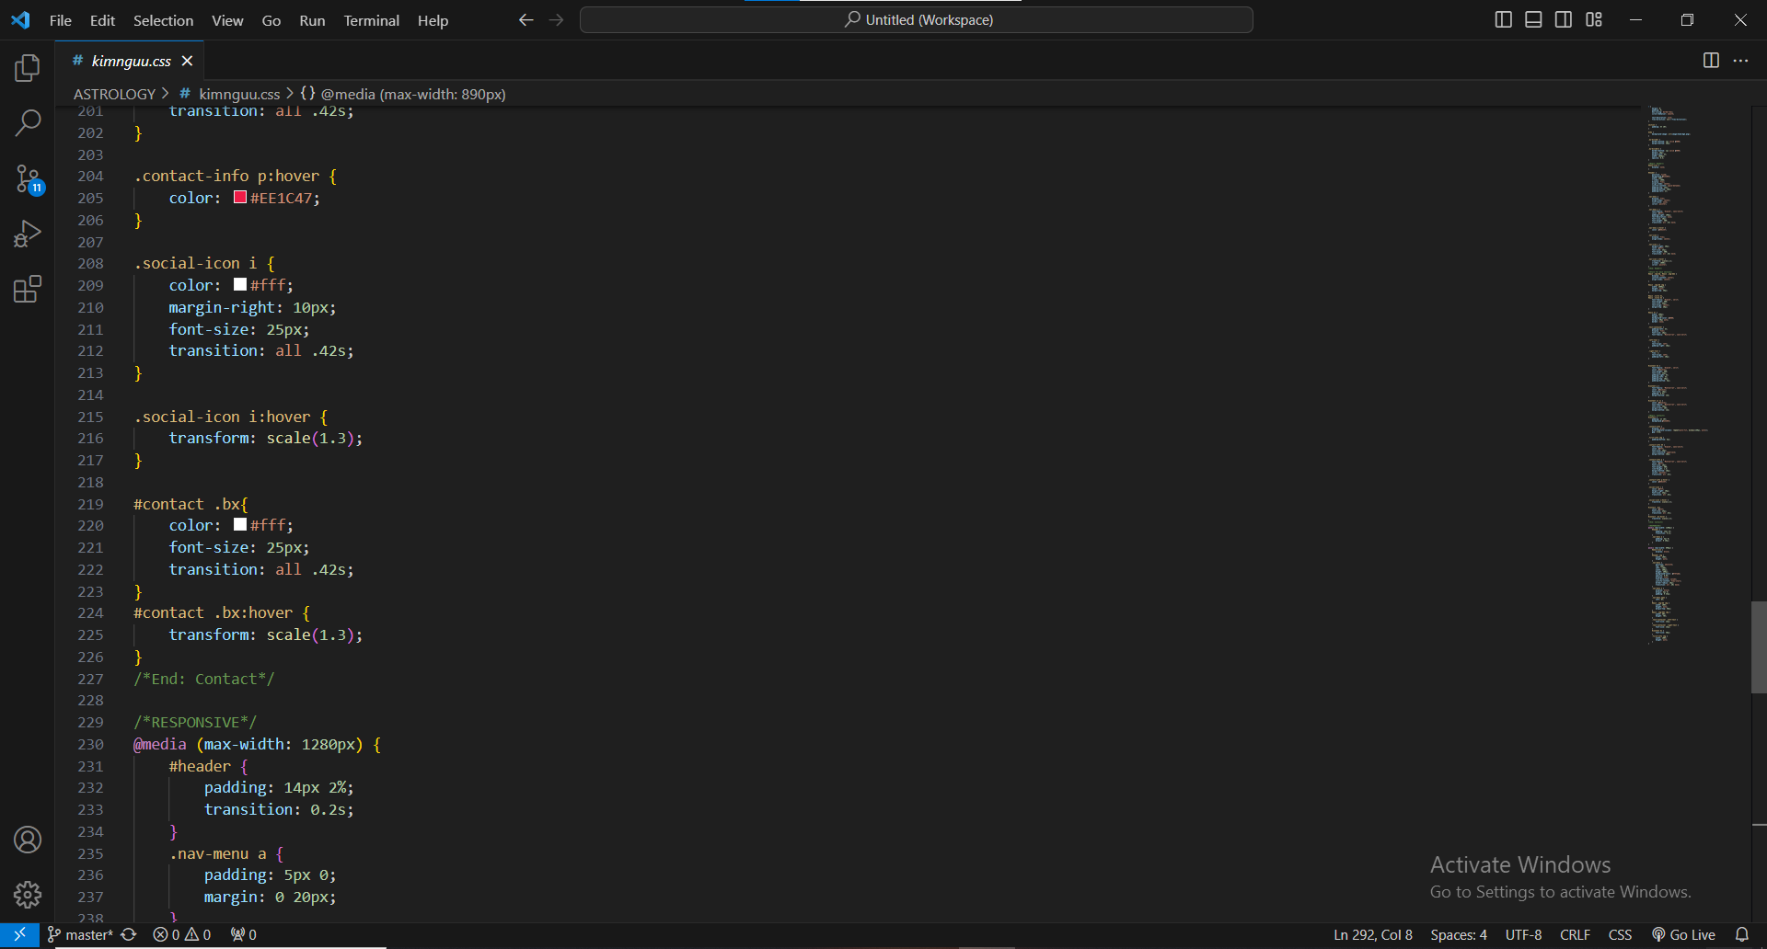

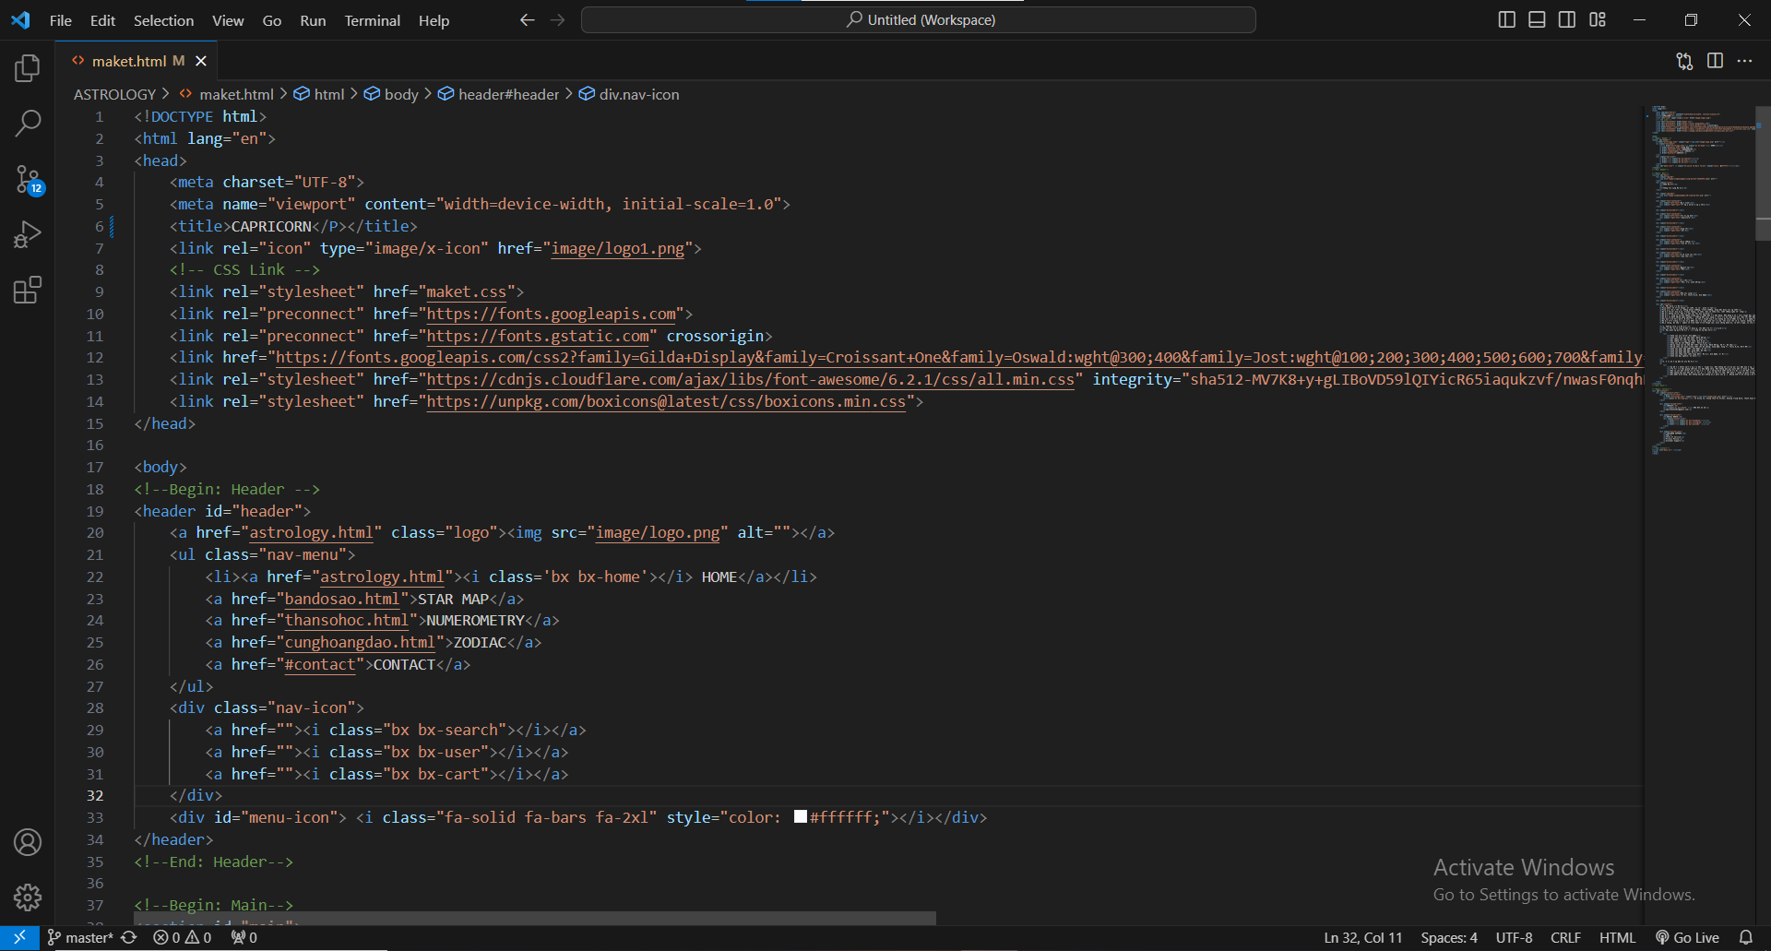

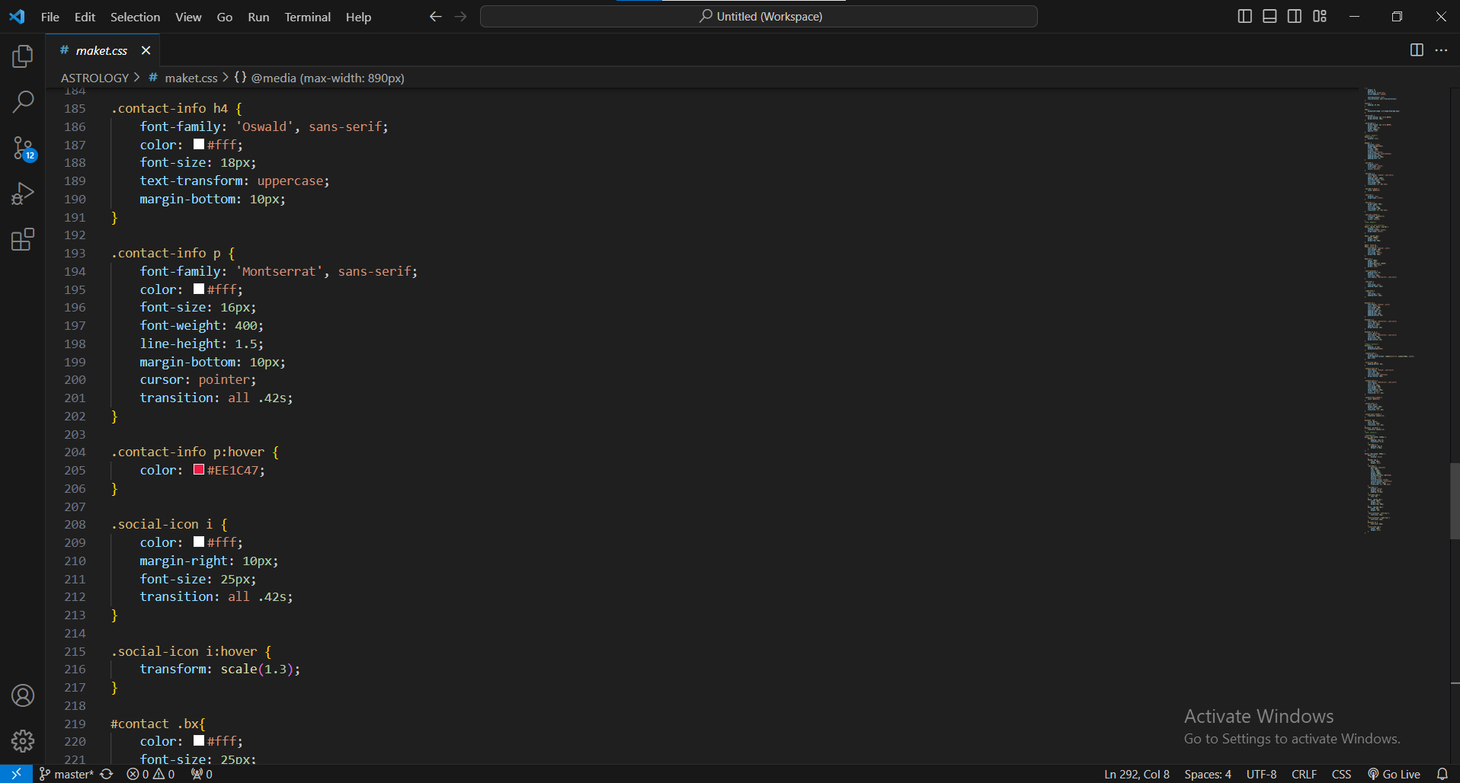

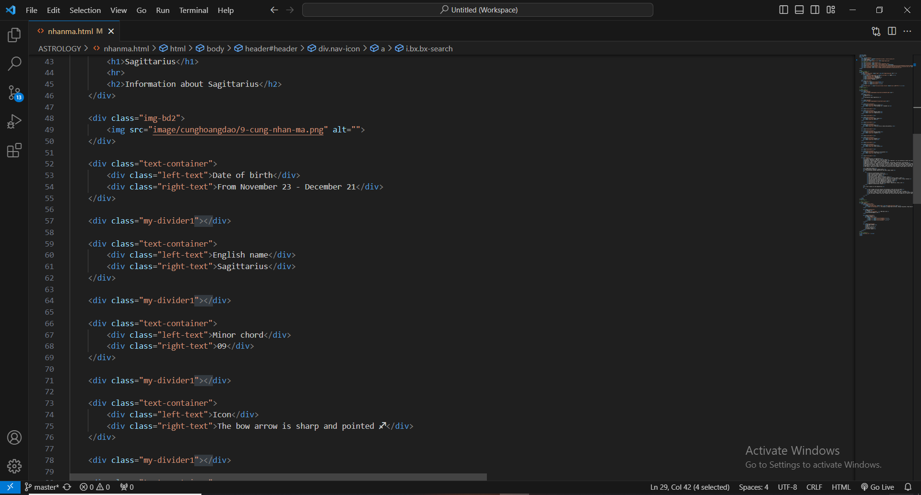

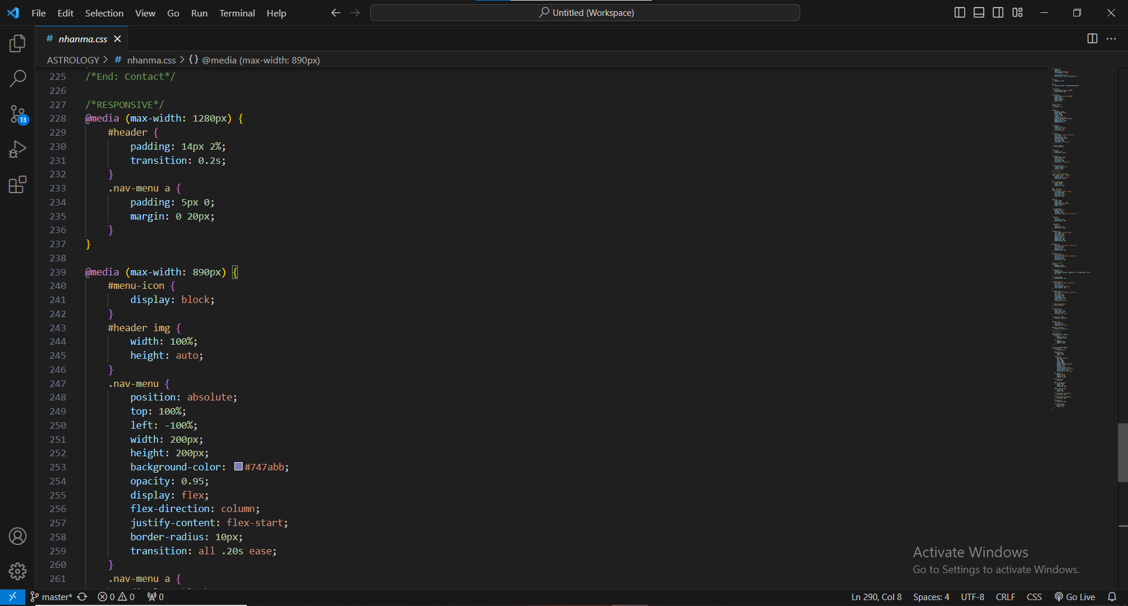

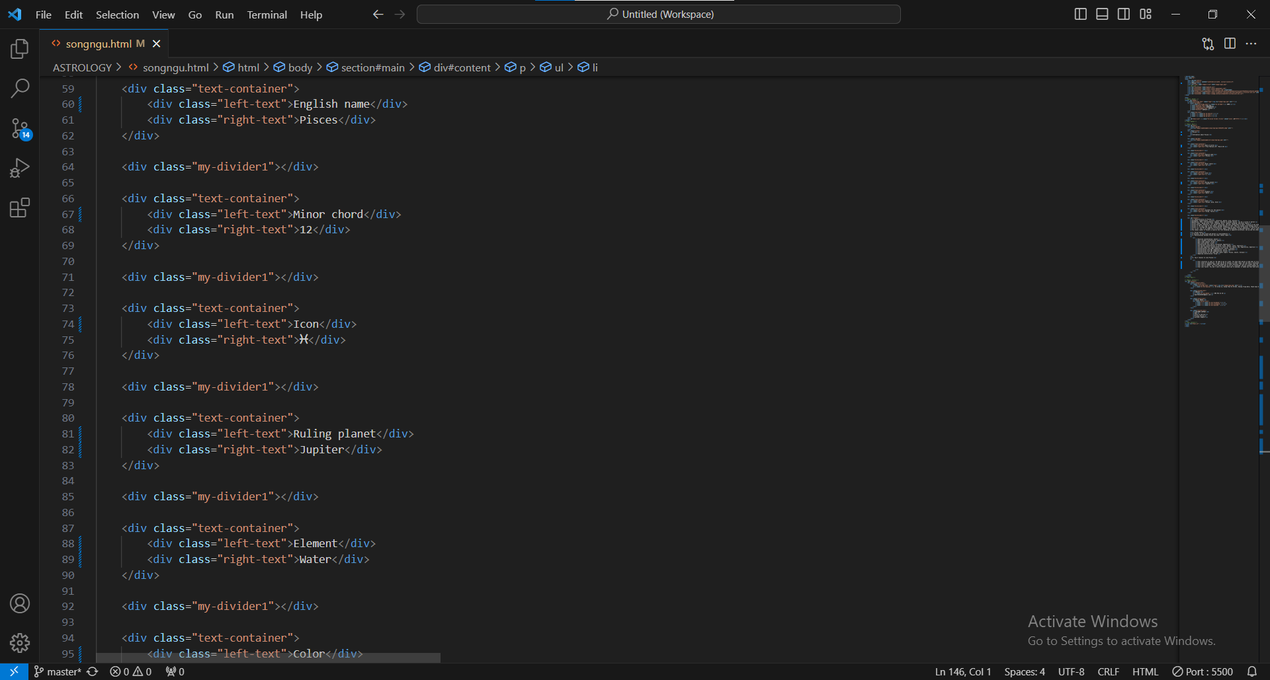

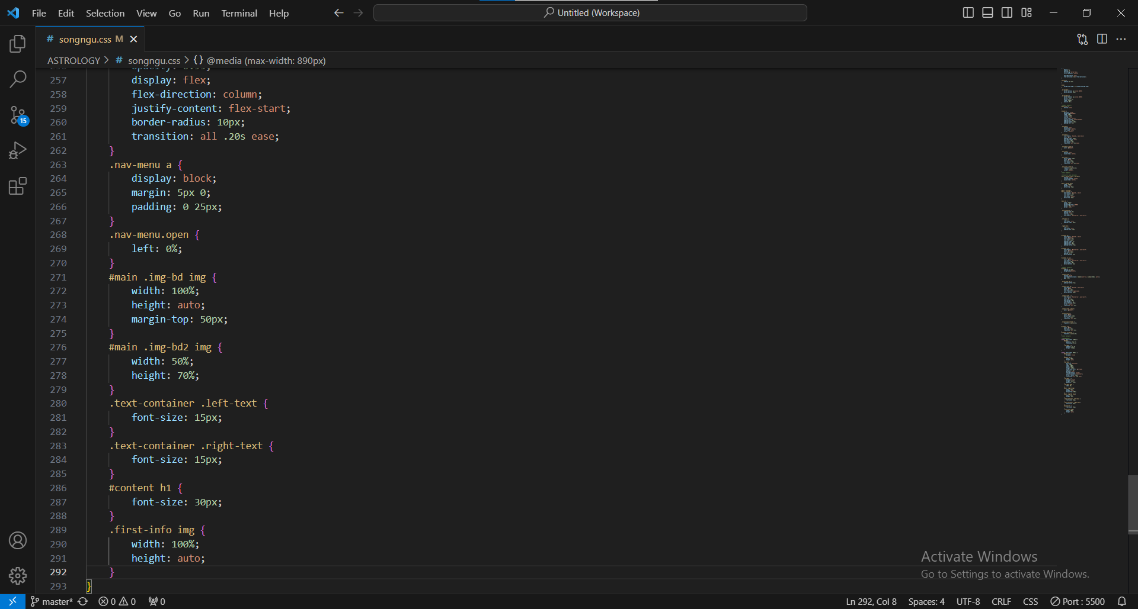

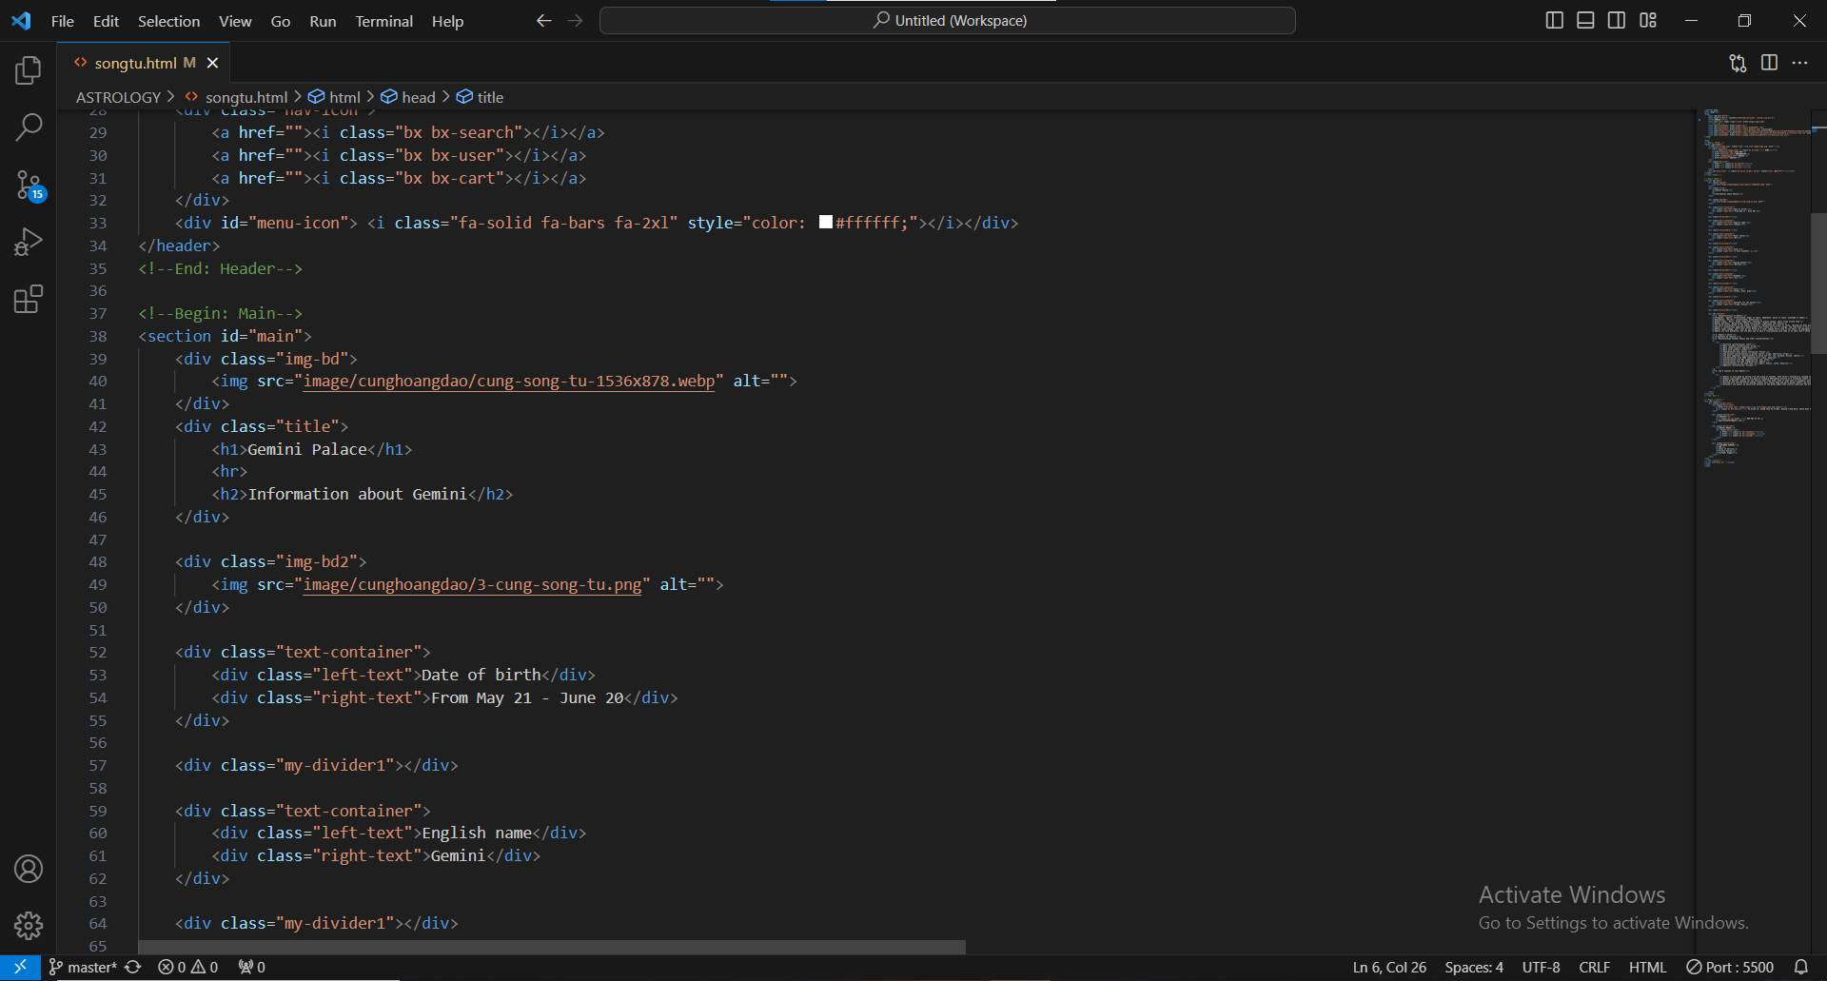

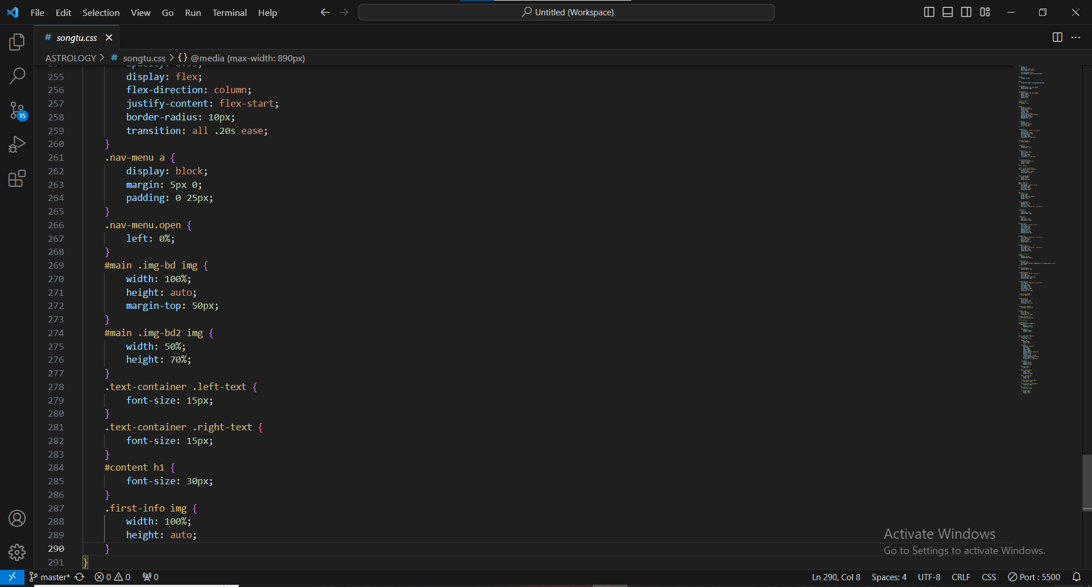

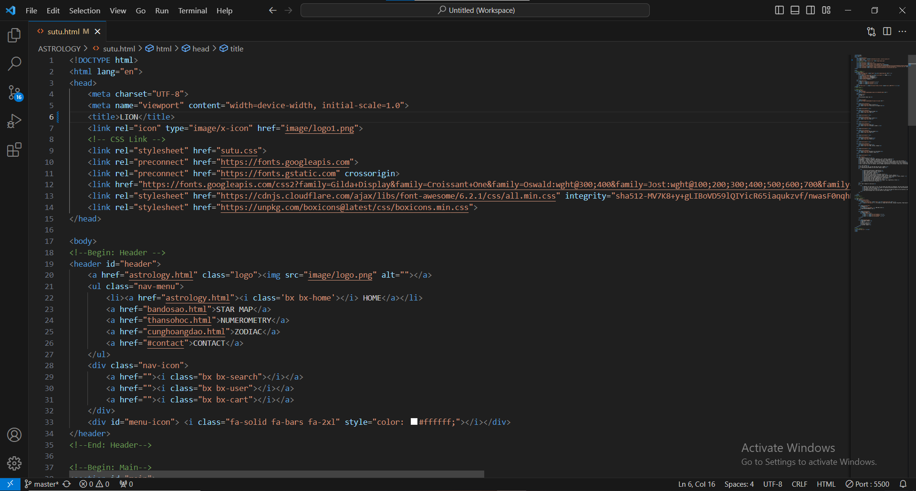

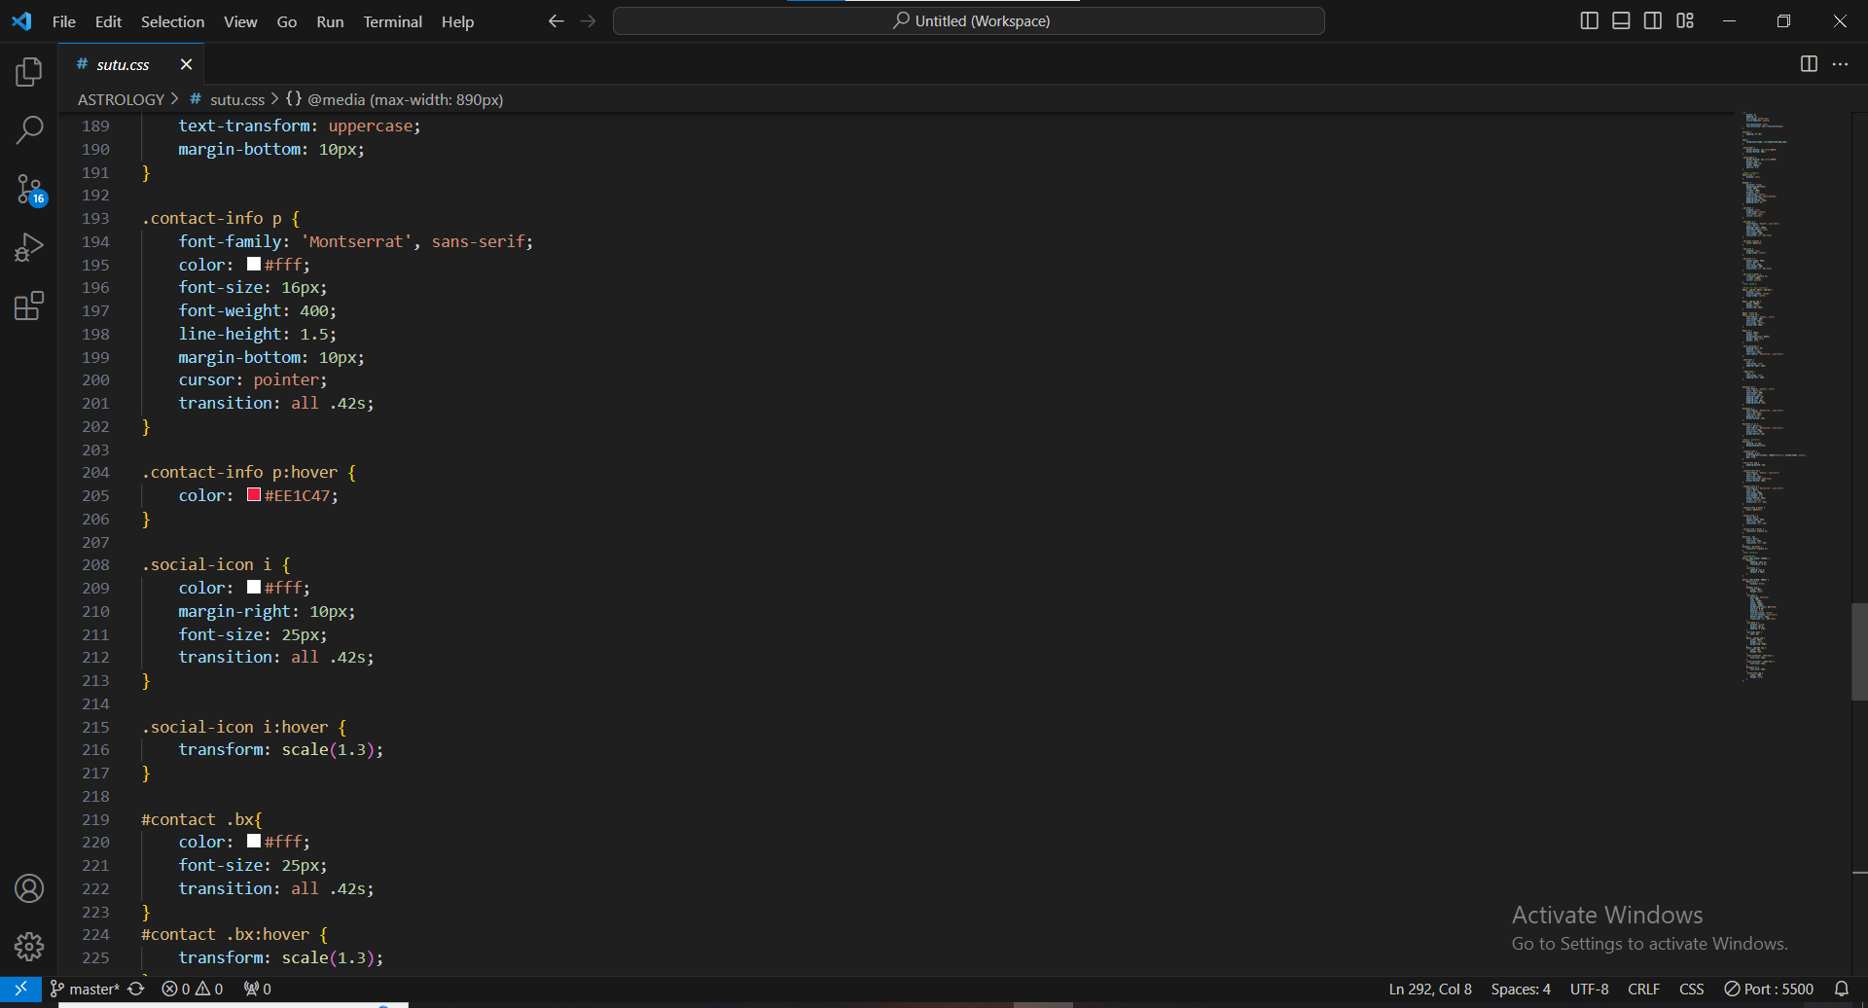

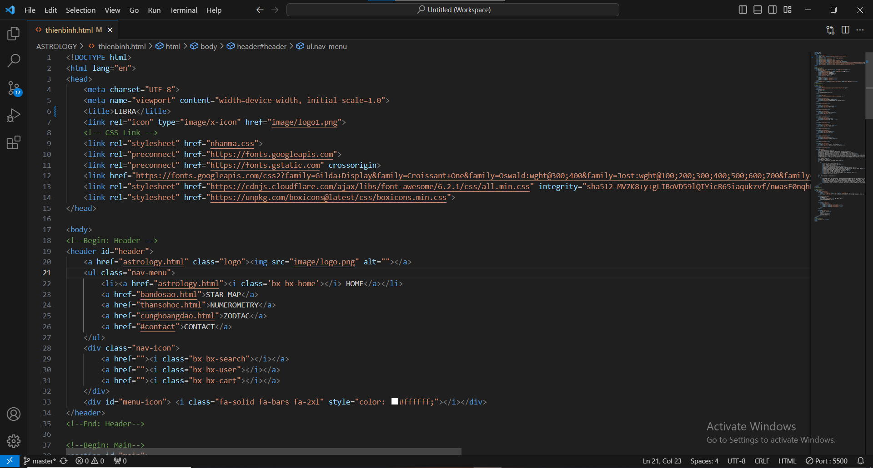

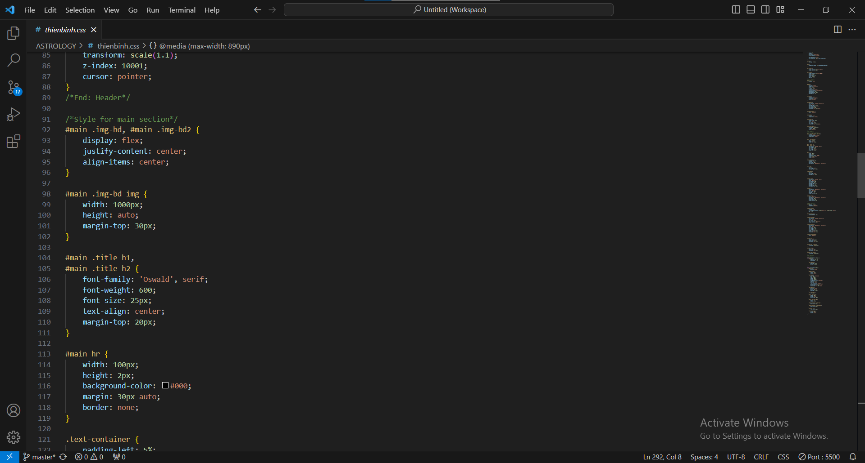

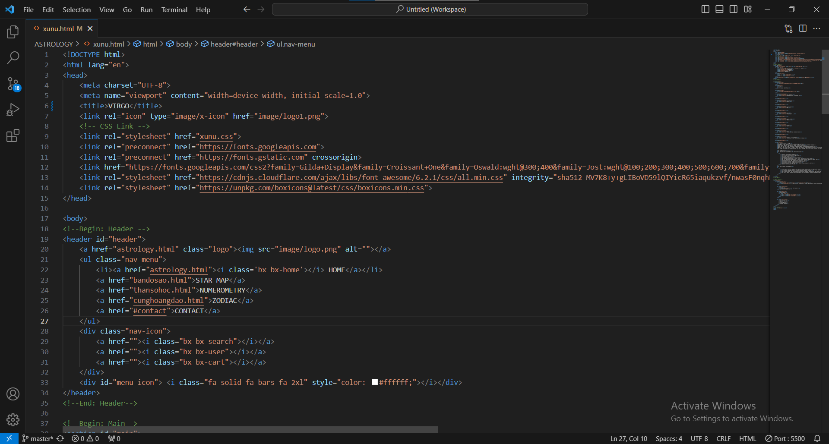

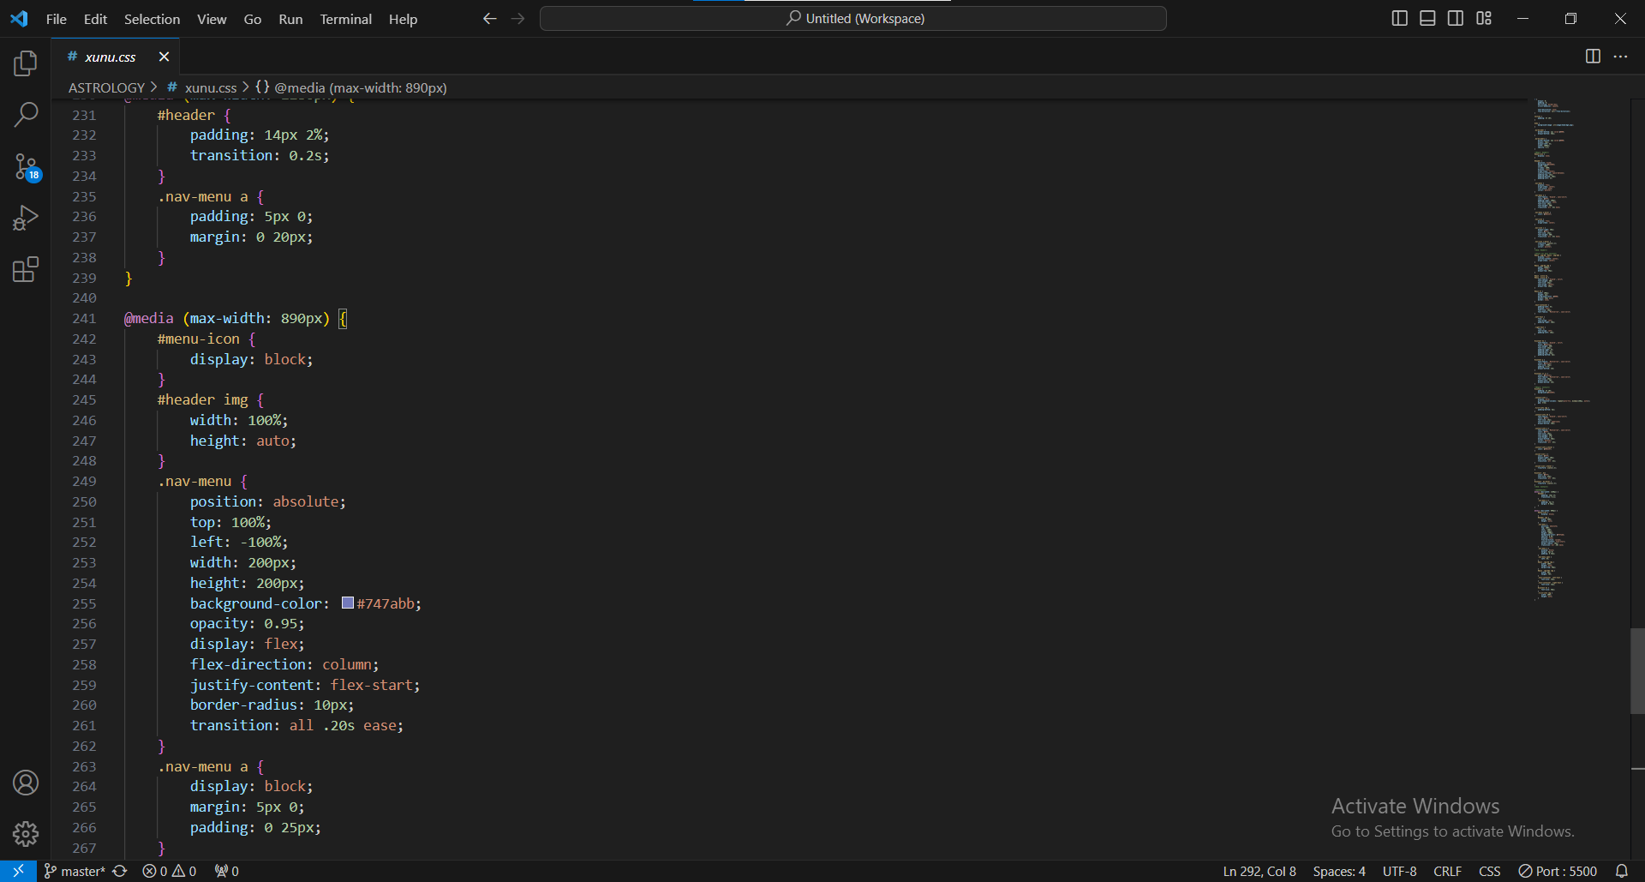

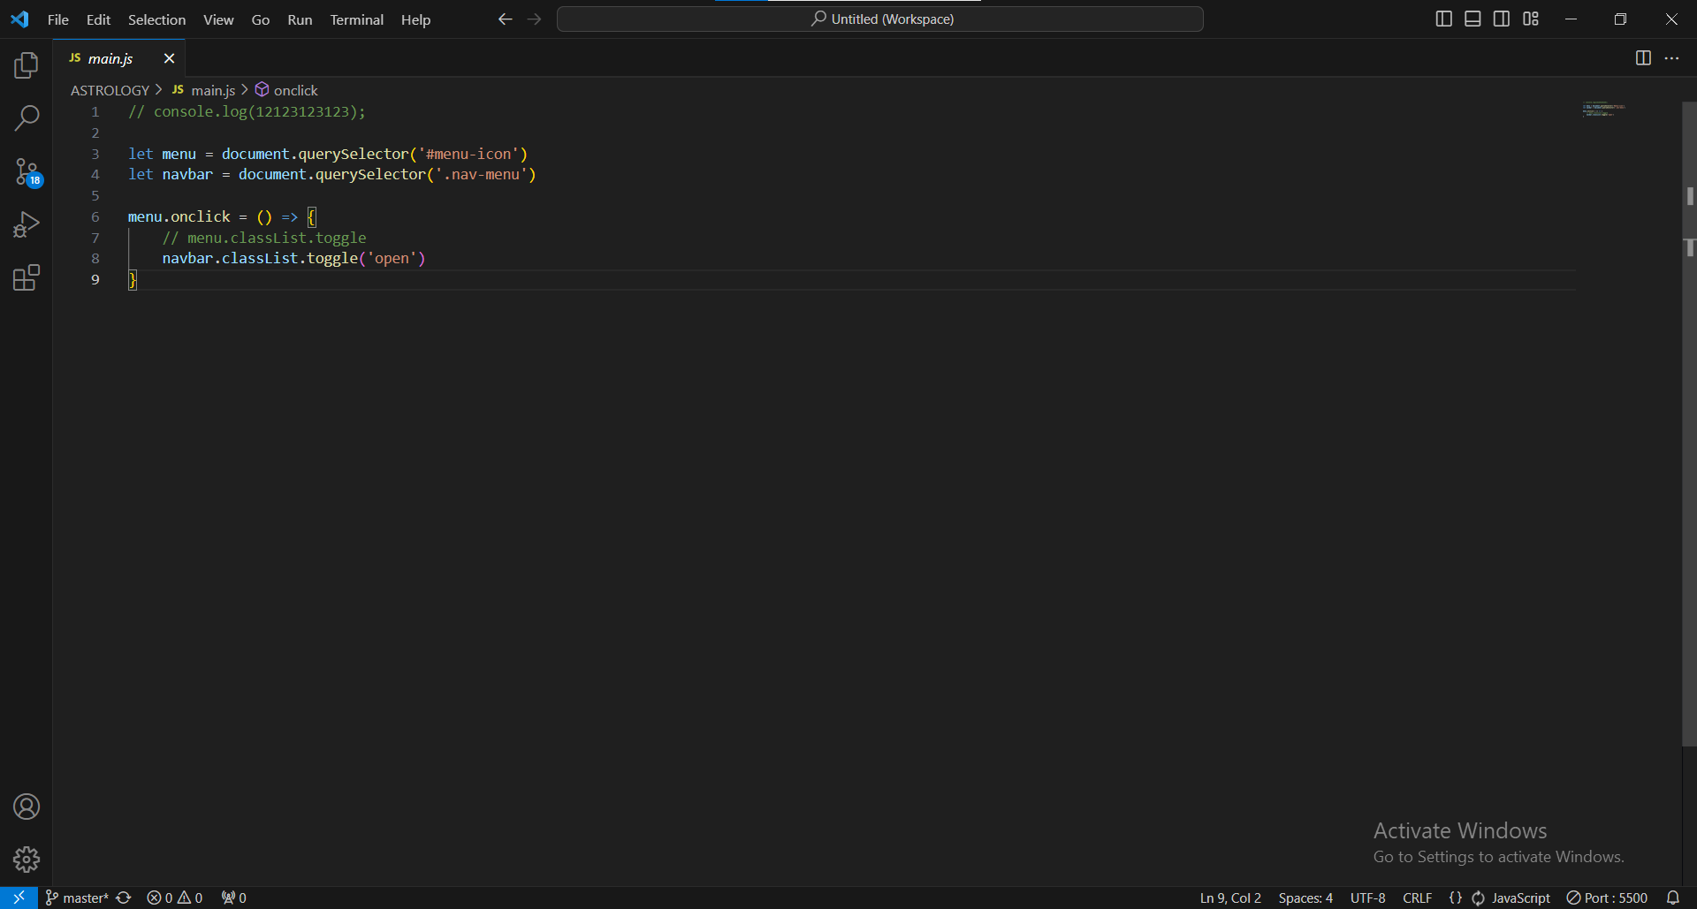

1. **Webpage Normal (16 pages)**

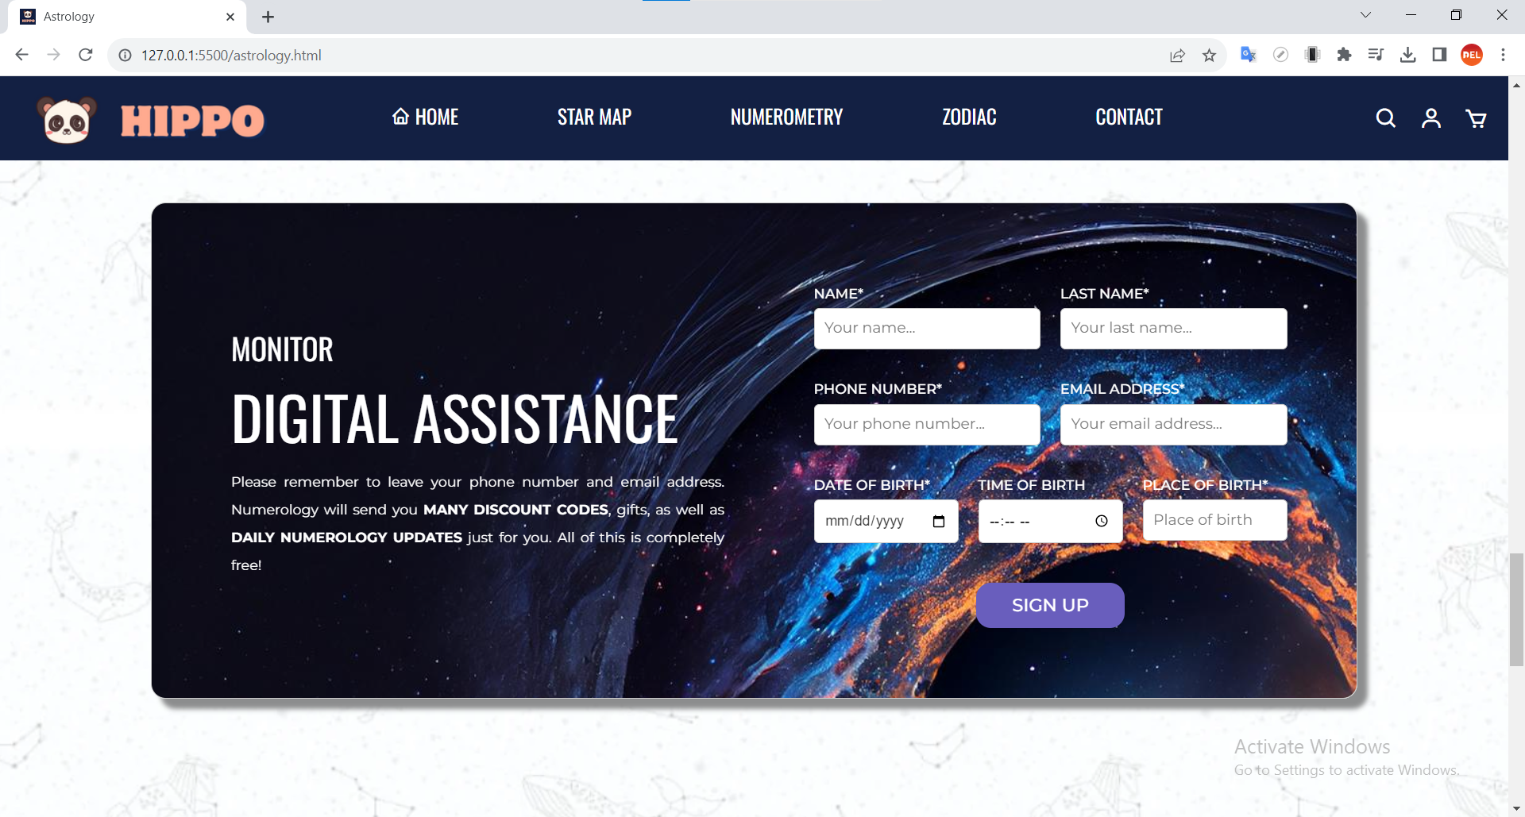

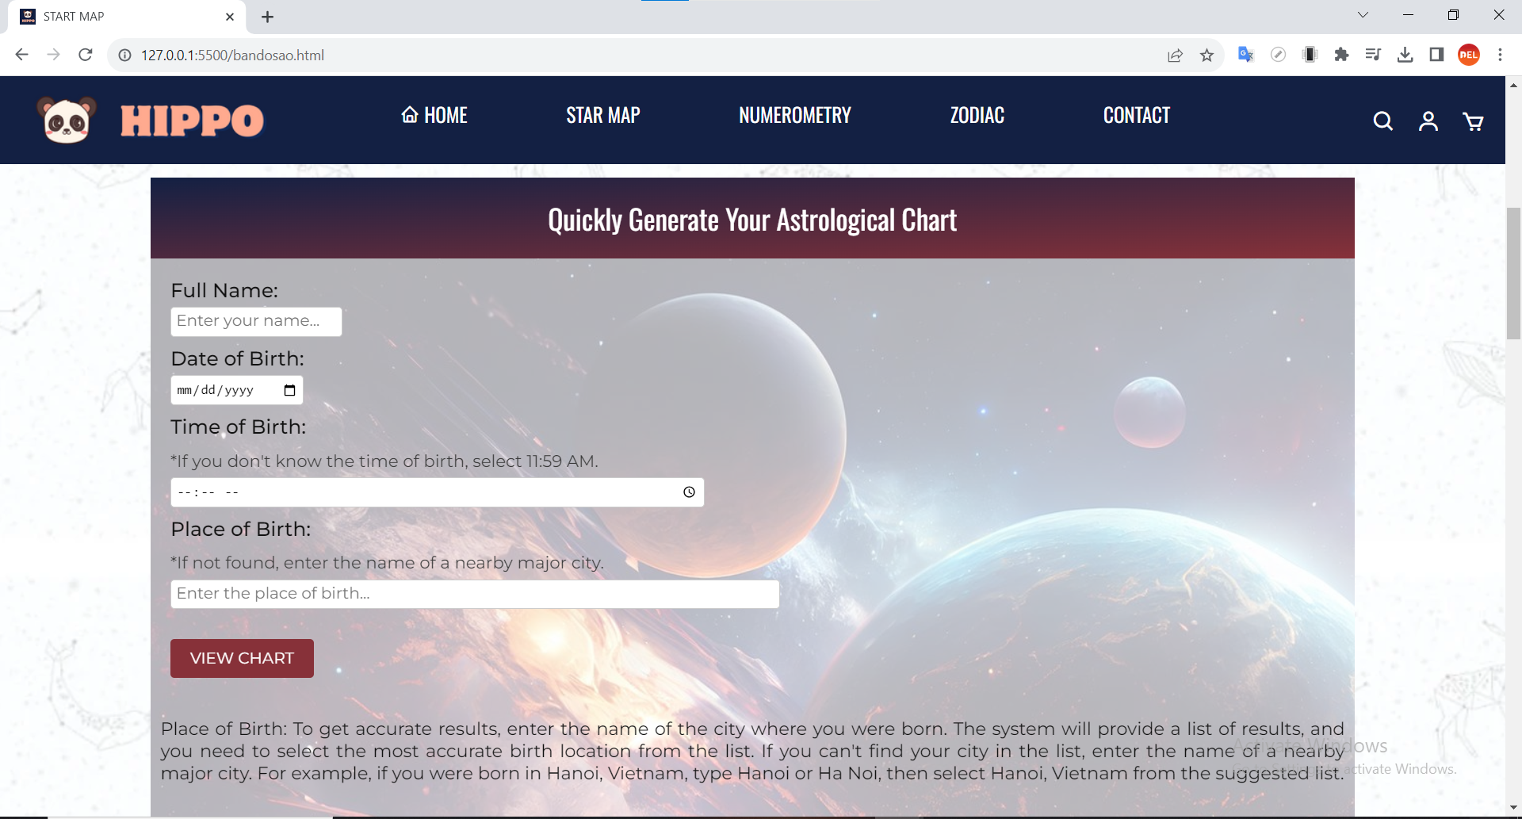

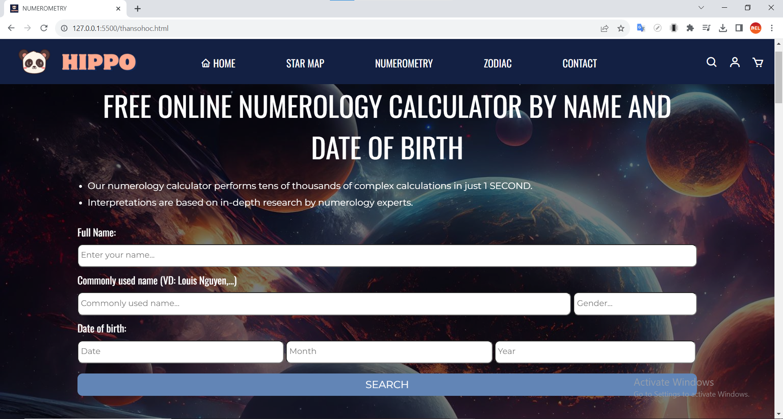

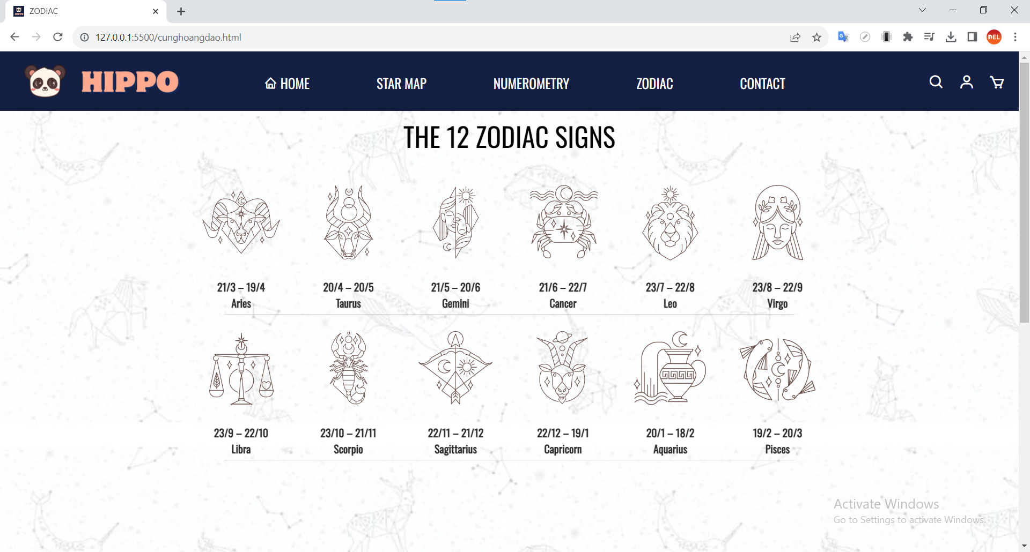

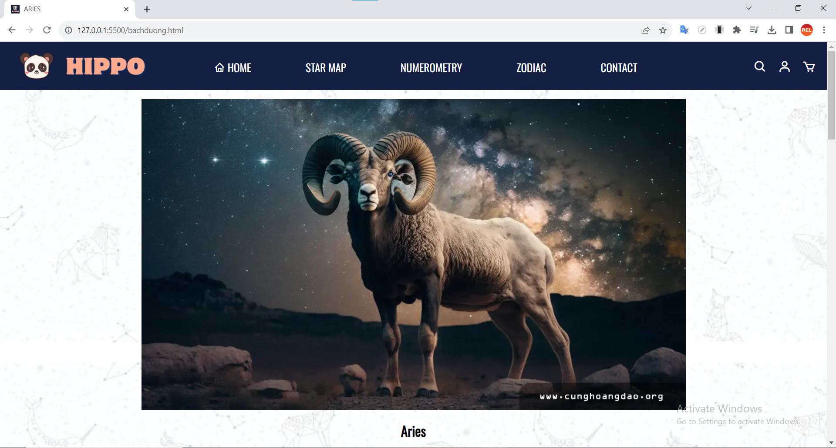

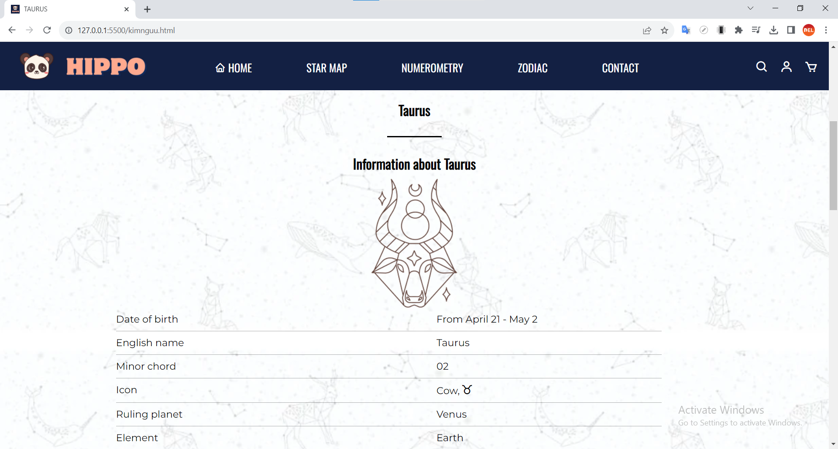

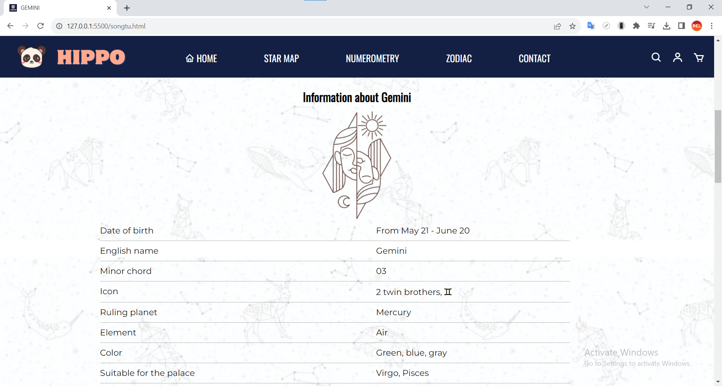

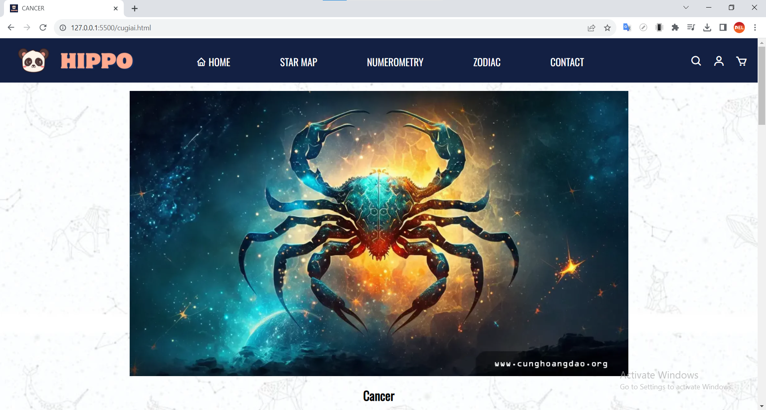

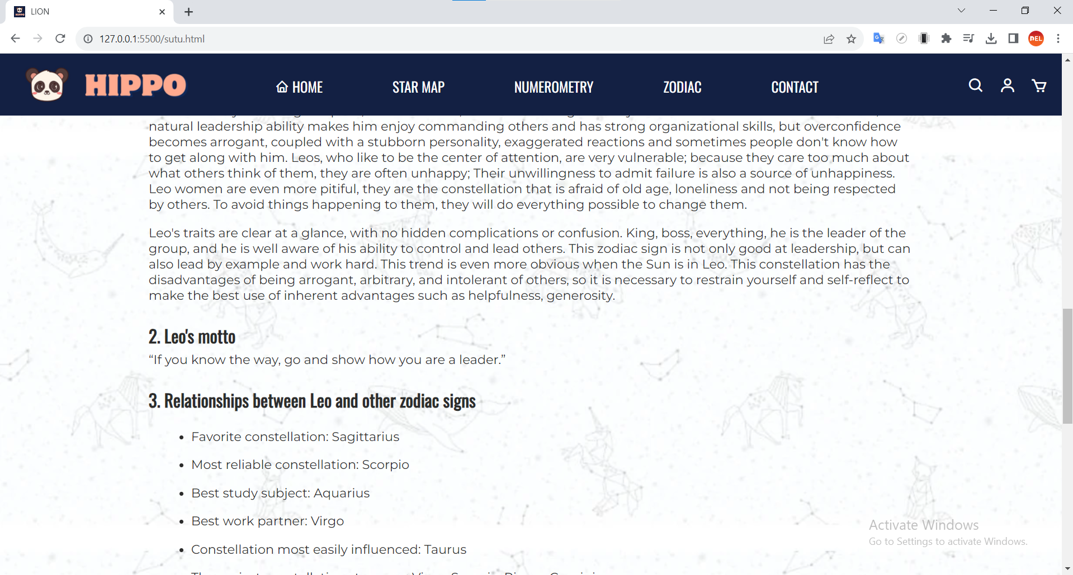

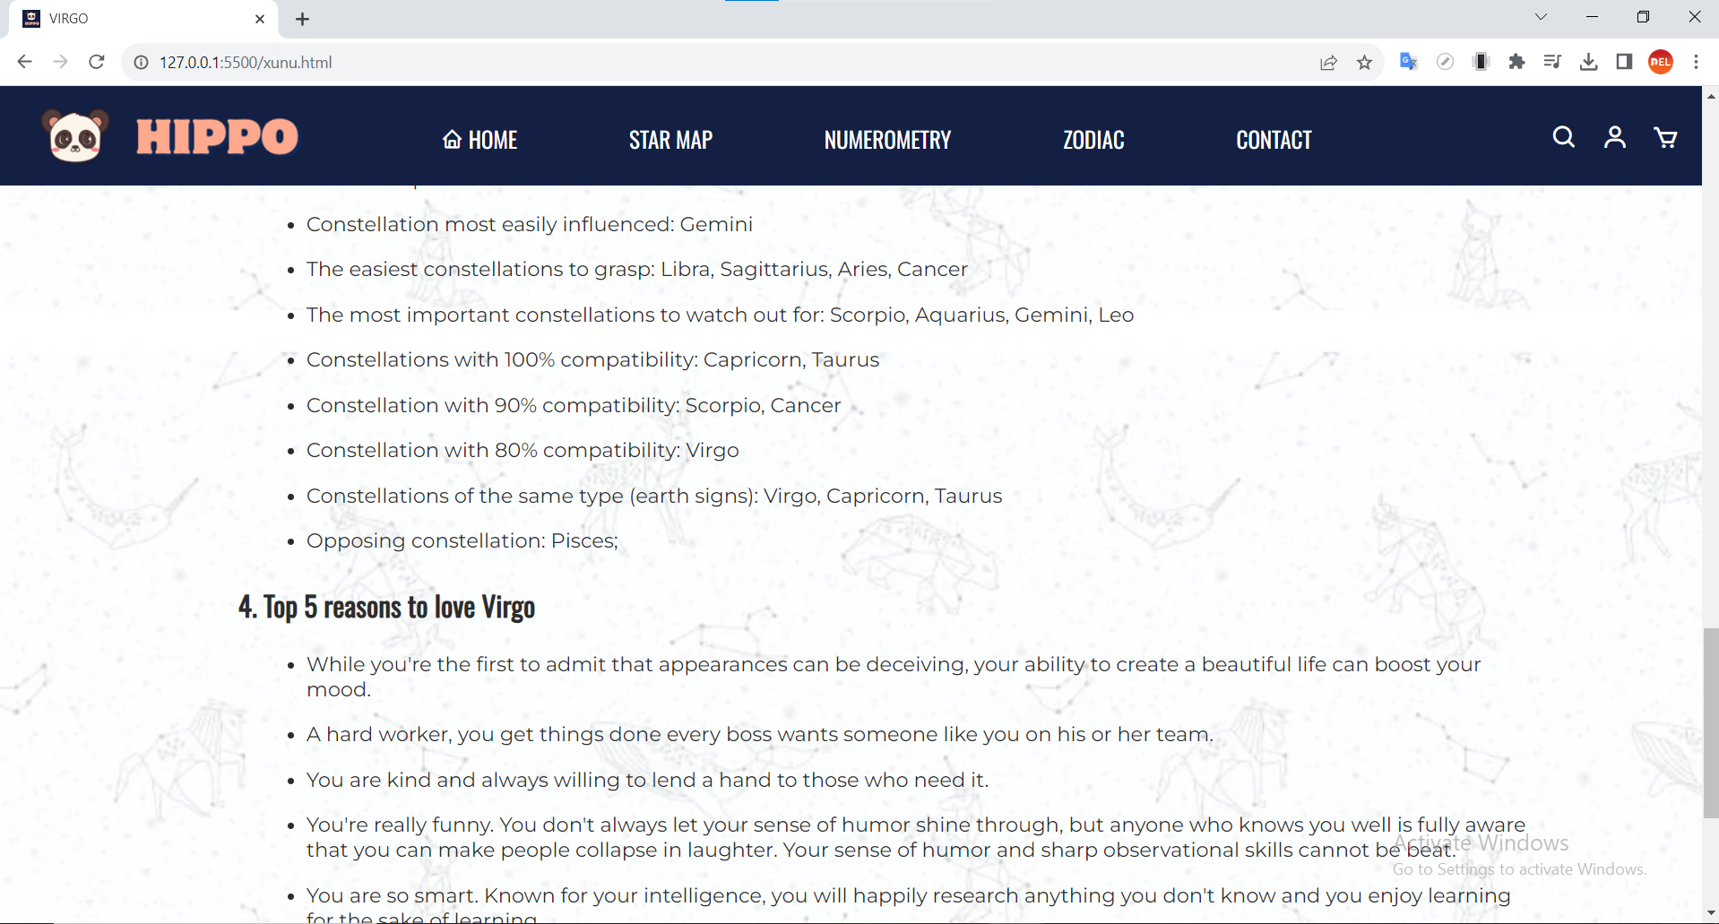

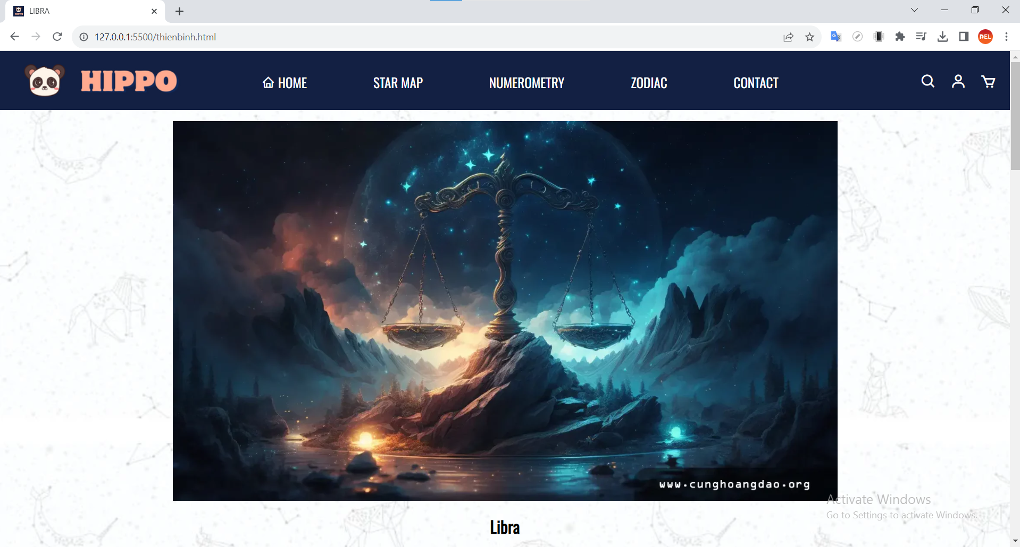

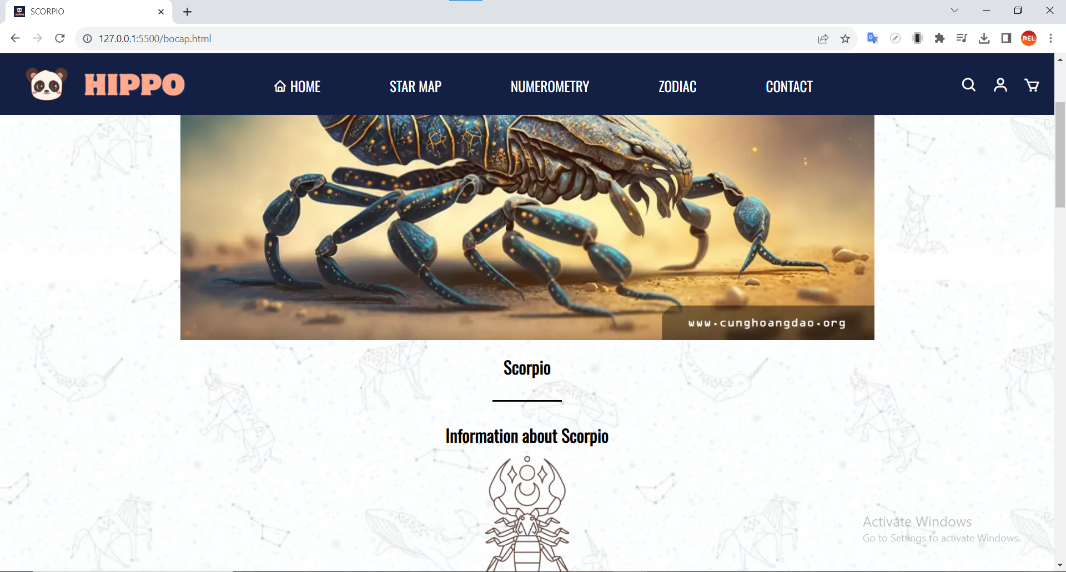

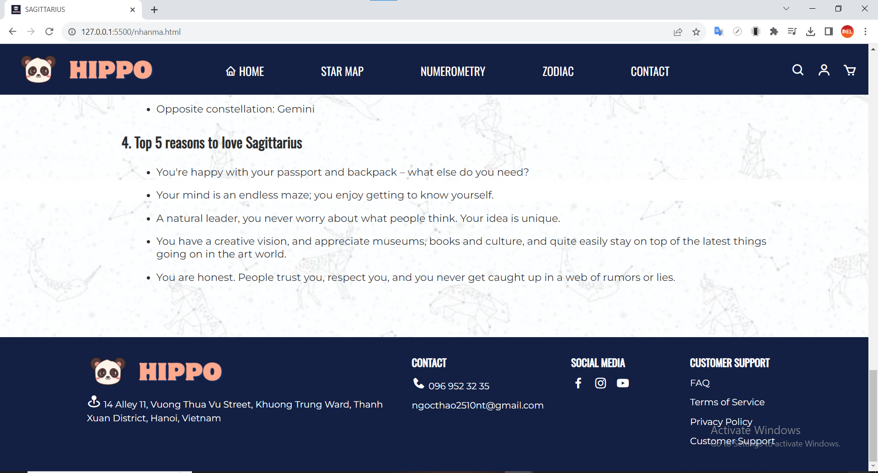

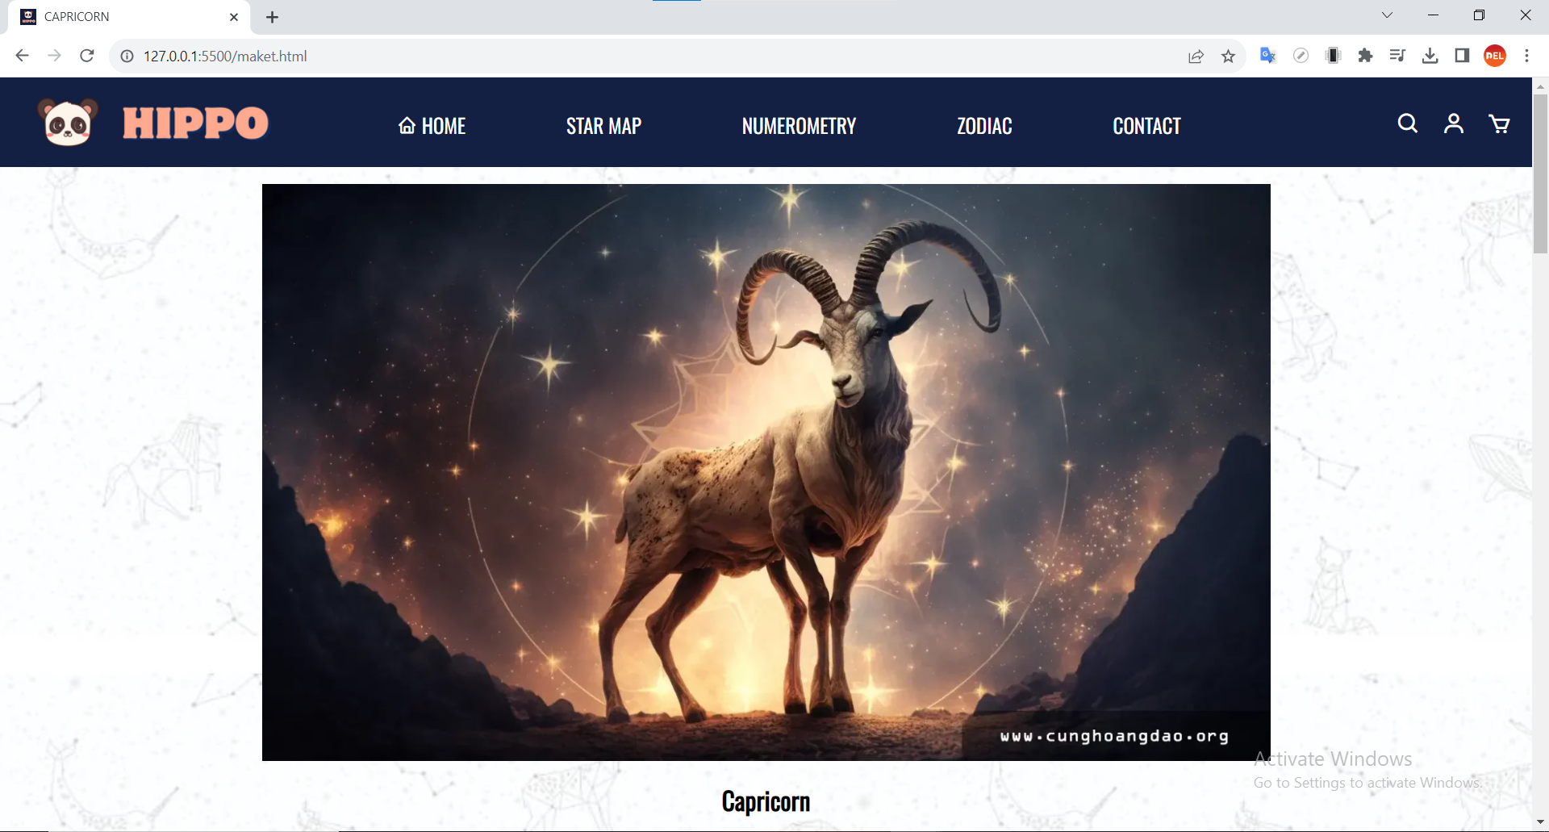

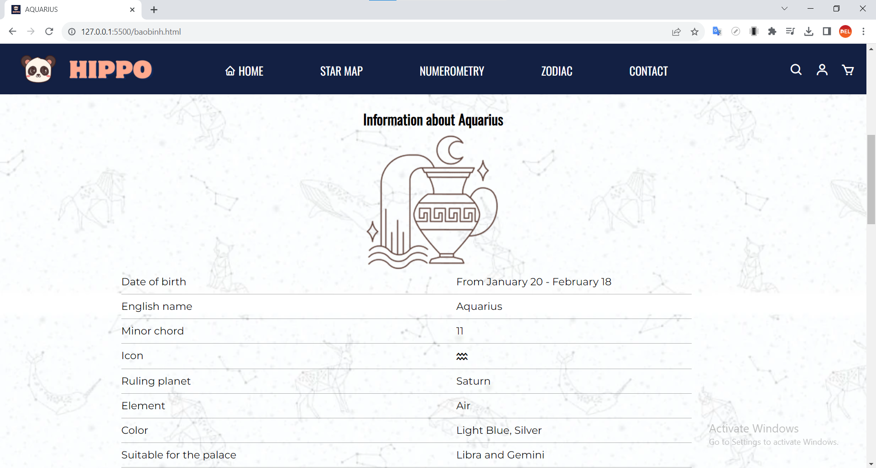

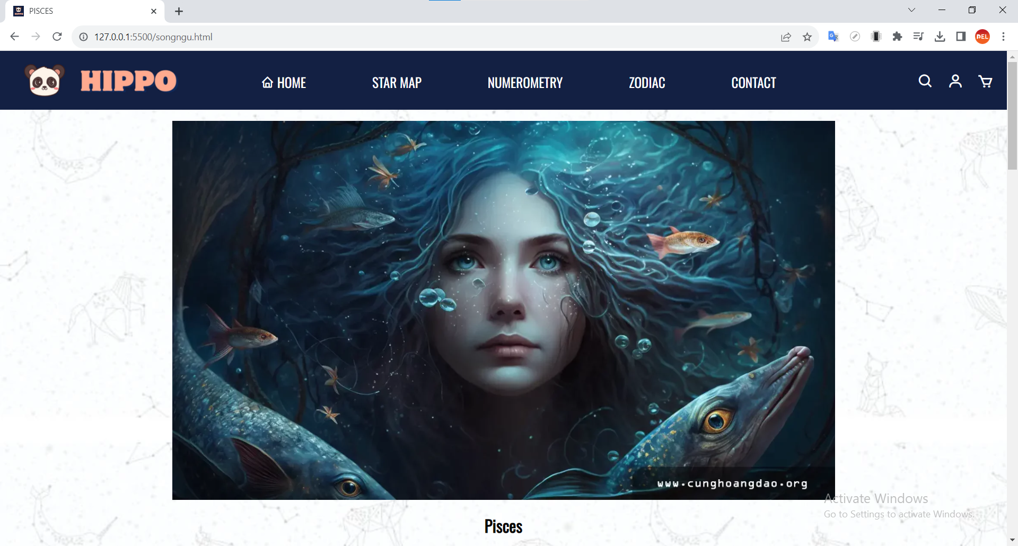

1. **Webpage Responsive (16 pages)**

* Desktop/Laptop:

https://drive.google.com/drive/folders/1-S_0L9P6Z68Dw473VkWP3Xxyh8hYhAYF?usp=share_link

* Ipad:

https://drive.google.com/drive/folders/1v063A42JYv2YlQih_4bGDT2jAxfLbMKQ?usp=sharing

* Iphone:

https://drive.google.com/drive/folders/1VlVwUhUXn6soIR0xYnzVLtKGjwz-IKcs?usp=sharing

* Android:

https://drive.google.com/drive/folders/1Y4fDt9rYIKcUounDNASGpDCjLU4d7A4_?usp=sharing